ICSA Member News April 2023
Highlights 3
ICSA Outreach and Engagement Committee 3
ICSA Events During JSM 3
ICSA Board Member Meeting (scheduled 6:00pm-9:00pm on Sunday, August 6, 2023) 3
ICSA General Member Meeting (scheduled around 5:00pm-6:30pm on Wednesday, August 9, 2023) 3
ICSA Banquet (scheduled around 7:00pm – 9:30pm on Wednesday, August 9, 2023) 4
ICSA Sponsored Sessions 4
The following sessions are sponsored and organized by ICSA. You are encouraged to join these sessions if your schedule allows. 4
ICSA 2023 Applied Statistics Symposium (June 11 – 14, 2023) 4
ICSA 2023 China Conference (June 30 – July 3, 2023) 5
The 12th ICSA International Conference (July 7 – 9, 2023) 5
Call for ICSA International Conference 2025 6
Corner to Celebrate ICSA Members 7
Cast Your Vote for ASA President-2024 by May 1, 2023 7
Congratulations to Dr. Joseph (“Joe”) C. Capelleri on Winning Long-Term Excellence Award 7
ICSA Springer Book Series in Statistics 8
Sponsored and Co-Sponsored Journals 8
ICSA Sponsored Journals 8
Statistics in Biosciences 8
Call for papers: Special Issue on Statistical Methods, Algorithms and Applications in Biomedical Data Integration 9
ICSA Co-sponsored Journal 9
Statistica Sinica 9
Upcoming ICSA Meetings 10
Upcoming Co-Sponsored Meetings 10
The 8th Workshop on Biostatistics and Bioinformatics (May 5 - 7, 2023) 10
Statistical Foundations of Data Science and their Applications: A conference in celebration of Jianqing Fan’s 60th Birthday (May 8 – 10, 2023) 11
Call for ICSA Invited Session proposals for the 2023 IISA Conference (June 1 – 4, 2023) 11
Dose Finding and Other Topics in Drug Development in Honoring Dr. Naitee Ting’s 70th Birthday (June 7 – 9, 2023) 12
The 2023 International Conference of Statistics and Data Science (July 12 – 13, 2023) 12
IMS Asia Pacific Rim Meeting (Postponed to January 2024) 13
Online Training and Seminars 13
Healthcare Innovation Technology: The Pod of Asclepius 13
Job Listings 14
Research Assistant Professor in Applied Statistics and Financial Mathematics / Engineering and Computational Mathematics / Applied Optimization and Operations Research / Data Science and Analytics (several posts) (Ref. 230324010) 14

Highlights

ICSA Outreach and Engagement Committee
ICSA initiated a new ad hoc committee, ICSA Outreach and Engagement Committee, chaired by Dr. Jin Zhou, with current members: Jun Zhao, Weining Shen, Chengsheng Jiang, Ming Wang, and Grace Li. The committee will be fully functioning after get consent from the board of directors.
The first task of this team is related to social media - a Twitter handle @ICSA_Statistics has been created. News from ICSA will be edited and (officially) posted at Twitter site. The ICSA members are encouraged to follow the account.

ICSA Events During JSM
Call for volunteers to serve ICSA activities during the 2023 JSM in Toronto Canada. The volunteers will work with the JSM local committee at the ICSA booth, in the ICSA membership meeting, and in the ICSA banquet. If you are interest, please contact the ICSA JSM Local Committee Dr. Dehan Kong (dehan.kong@utoronto.ca), Linbo Wang (linbo.wang@utoronto.ca), or the ICSA executive director Dr. Jun Zhao (executive.director@ICSA.org).

ICSA Board Member Meeting (6:00pm-9:00pm on Sunday, August 6, 2023)
This meeting is open for ICSA Board Members and invited members only.

ICSA General Member Meeting (scheduled around 5:00pm-6:30pm on Wednesday, August 9, 2023)
The meeting will be open to all members. ICSA 2023 awards will be presented, and the 2023 election results will be announced. Please join us to meet ICSA leadership team and to get connected in person with other members. Refreshment will be provided.

ICSA Banquet (scheduled around 7:00pm – 9:30pm on Wednesday, August 9, 2023)
This will be a great opportunity for ICSA members to get connected and have fun together.

ICSA Sponsored Sessions

The following sessions are sponsored and organized by ICSA. You are encouraged to join these sessions if your schedule allows.
Date/Day | Time | Title | Type
Aug 7, Mon | 10:30am - 12:20pm | Statistics in Biosciences | Invited
 | 2:00pm - 3:50 pm | Advanced Models for Analysis of Event-time Data | Topic-Contributed
Aug 8, Tue | 10:30am - 12:20pm | Some New Methods in Biostatistics | Contributed
 | 2:00pm - 3:50pm | Machine Learning Methods for Precision Medicine | Invited
Aug 9, Wed | 8:30am - 10:20pm | Advanced Developments in Survival Analysis | Topic-Contributed
 | 10:30pm - 12:20pm | Some New Statistical Methods | Contributed
Aug10, Thu | 8:30am - 10:20pm | Application of Causal Inference Methods in RCTs with Treatment Switching – the Latest Development | Topic-Contributed
TBD | TBD | Contributed Poster Presentation: ICSA | Contributed Poster

ICSA 2023 Applied Statistics Symposium (June 11 – 14, 2023)
The ICSA 2023 Applied Statistics Symposium will be held at the University of Michigan, Ann Arbor, MI. For scientific session proposals, interests, and questions, please contact the co-Chairs of the Organizing Committee, Dr. Jian Kang (jiankang@umich.edu) and Dr. Gongjun Xu (gongjun@umich.edu). For detailed information and key dates, please refer to the link: 2023 ICSA Applied Statistics Symposium. Registration is open. Accommodation details refer to the link: Accommodation – 2023 ICSA Applied Statistics Symposium. Stay tuned on the program details of the symposium, including the keynote speeches, scientific sessions, the board meeting (4:00pm-7:00pm) on June 11, 2023, the Welcome Reception and Mixer on June 11, 2023, the ICSA membership meeting on June 13, 2023, and the banquet on June 14, 2023.

ICSA 2023 China Conference (June 30 – July 3, 2023)
The 2023 ICSA China Conference will be held at Chengdu, Sichuan, China from June 30 – July 3, 2023. It will be co-sponsored by the Southwest Jiaotong University (SWJTU). The conference venue is at Jinniu Hotel (金牛宾馆) in Chengdu, China. The hotel information can be found at 首页 - 四川省人民政府金牛宾馆-官方网站-在线客房预订 (jnhotel.com). The organizing committee has negotiated a special rate of the hotel rooms for the conference attendees with first come first served basis. You can book rooms from April 22 to June 20, 2023. For more information, please contact the conference Chair Professor Haitao Zheng at htzheng@swjtu.edu.cn, or the Scientific Program Committee Chair, Professor Yichuan Zhao at yichuan@gsu.edu, or visit this website: https://maths.swjtu.edu.cn/english/ICSA_2023_China_Conference.htm. Registration is open.

The 12th ICSA International Conference (July 7 – 9, 2023)
The 12th ICSA International Conference will be held in person at Henry Cheng International Conference Center, Cheng Yu Tung Building, the Chinese University of Hong Kong, Hong Kong, from July 7 to July 9, 2023. For information, please contact Scientific Program Committee Chair Professor (Tony) Jianguo Sun at sunj@missouri.edu or Co-Chair Professor Xingqiu Zhao at Xingqiu.Zhao@polyu.edu.hk. For detailed information, please refer to this site: 12th ICSA International Conference (https://international2023.icsa.org/). For inquiries, go to international2023@icsa.org. Registration is open.
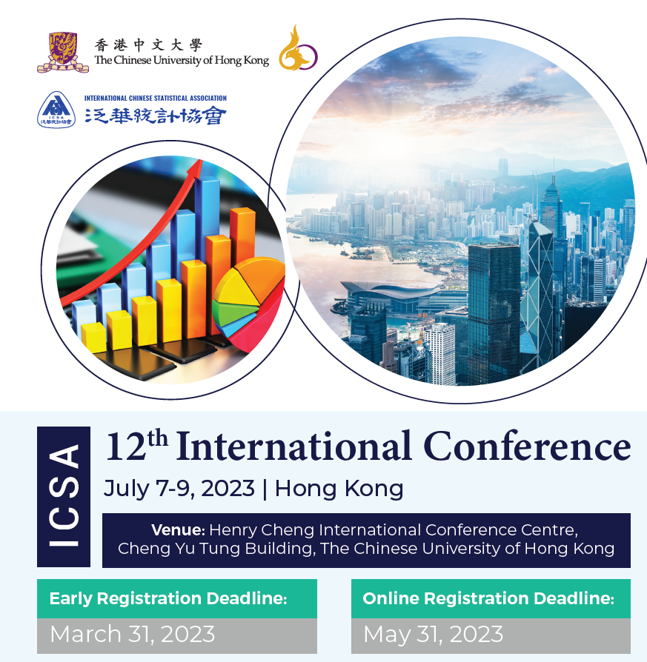

Call for ICSA International Conference 2025
ICSA Program Committee invites respected members of the ICSA community to submit their interest in organizing the 13th ICSA International Conference to be held in 2025. Please note that the candidate location should be in mainland China or Taiwan or other places in Asia. The expression of interest to host the conference are to be submitted via email to ICSA PC chair Prof. Xinping Cui at xinping.cui@ucr.edu or Executive Director Dr. Jun Zhao at executive.director@icsa.org, including the information about the expected date, location, general chair and tentative PC chairs.

Corner to Celebrate ICSA Members
This section is created to highlight the achievements of our members. All ICSA members are encouraged to contact Dr. Jun Zhao, the ICSA Executive Director (executive.director@icsa.org) with the brief introduction about themselves and the award.

Cast Your Vote for ASA President-2024 by May 1, 2023
The ASA announces the candidates for the 2023 election. Voting begins April 3rd and runs through May 1st. ICSA members who are also ASA members are encouraged to cast your vote in the ASA election. The following candidates are ICSA permanent or active members.
Running for ASA President-Elect 2024: Dipak Dey, Ji-Hyun Lee
Running for ASA Vice President 2024-2026: Kelly Zou (action plan: Count on Your Vote! - YouTube)
Running for ASA Biopharmaceutical Chair-Elect 2024: Yongming Qu, Eli Lilly and Company
For details, please click this link: https://magazine.amstat.org/blog/2023/03/01/2023election/.

Congratulations to Dr. Joseph (“Joe”) C. Capelleri on Winning Long-Term Excellence Award

Dr. Joe Cappelleri, New England Statistical Society Past President, adjunct professor of Biostatistics at Brown and Executive Director of Biostatistics at Pfizer, was honored by the American Statistical Association’s (ASA) Health Policy Statistics Section (HPSS) with the Long-Term Excellence award during the 2023 International Conference of Health Policy Statistics (ICHPS) which was held at the Scottsdale, Arizona from Jan 9th to 11th, 2023. For detailed information, please refer to the following links:

https://nestat.org/news/2023/01/award
https://statistics.uconn.edu/2023/01/14/adjunct-prof-joseph-cappelleri-wins-hpss-long-term-excellence-award
https://www.brown.edu/academics/public-health/biostats/news/2023/01/joe-cappelleri-wins-long-term-excellence-award

ICSA Springer Book Series in Statistics
The editor of ICSA Springer book series in statistics, Dr. Din Chen, has reported that there are 24 books in the series now. Two new books were published in 2022 with detailed message below. If you plan to write books in the series, please contact Dr. Din Chen (Ding-Geng.Chen@asu.edu).
Emerging Topics in Modeling Interval-Censored Survival Data
Editor: Jianguo Sun & Ding-Geng Chen
Copyright: 2022
Published: 15 December 2022

Advances and Innovations in Statistics and Data Science
Editors: Wenqing He, Liqun Wang, Jiahua Chen & Chunfang Devon Lin
Copyright: 2022
Published: 28 October 2022

Refer to this site for all other books’ information.

Sponsored and Co-Sponsored Journals

ICSA Sponsored Journals

Statistics in Biosciences
The published new issue is Volume 15 Issue 1 in December 2022
Statistics in Biosciences | Volume 15, issue 1 (springer.com)
Recently accepted articles can be found at the journal website
https://link.springer.com/journal/12561/onlineFirst/page/1
A link for submitting your article to SIBS online is below
https://www.editorialmanager.com/sibs/default.aspx

Call for papers: Special Issue on Statistical Methods, Algorithms and Applications in Biomedical Data Integration
Integrating multiple data sources has attracted wide interests as part of transition from data to knowledge with the potential to change the analytical scheme of modern biomedical research. In recent years, research initiatives have been created to leverage large-scale observational
databases from multiple scientific disciplines and technologies, which present many significant methodological and computational challenges to traditional statistical methods and algorithms. Most notably, data collected from observational studies are leveraged for modern biomedical research to enrich study populations and improve controlling confounding factors. Despite infrastructure advancements, methodological and algorithmic challenges remain the barriers for data integration. Common analytical concerns in data integration include data storage and communication restrictions, statistical efficiency, protection of data privacy and against adversarial attacks, data harmonization over different formats, handling of missing data, heterogeneity across data sources, and external validity, among many others. Some new methods, algorithms and applications for data integration are being developed, but much remains unknown in terms of how well they perform or how they compare with conventional approaches. Moreover, with the ubiquitous availability of multi-source data and the increased desire to conduct research with massive data, new methodological and algorithmic developments are needed on many fronts of data integration, including uncertainty quantification, causal inference, and sparse and scalable analytical procedures.
The deadline for submissions is August 31, 2023.
Papers for the special issue should be submitted using the journal’s submission system at https://www.editorialmanager.com/sibs/default1.aspx. In the system, please choose the special issue on Statistical Methods, Algorithms and Applications in Biomedical Data Integration.
Co-Editors for the special issue:
Peter X.K. Song, Ph.D., the University of Michigan. Email: xsong@umich.edu
Lu Tang, Ph.D., University of Pittsburgh. Email: lutang@pitt.edu

ICSA Co-sponsored Journal

Statistica Sinica
Statistica Sinica is co-sponsored by Institute of Statistical Science Academia Sinica (ISSAS) https://www.stat.sinica.edu.tw/eng/index.php. Forthcoming papers' information is available at http://www3.stat.sinica.edu.tw/statistica/. The new issue (Volume 33, Number 2, 2023) is published.
There are two online special issues for your references:
Online Special Issue I (539-651): Causal Inference and Short Notes
Online Special Issue II (2295-2519): In Honor of Professor Ker-Chau Li

ICSA members have access to these articles via the "membership only area" at http://www.icsa.org. If you have any problems with subscription, please contact the editorial office through ss@stat.sinica.edu.tw.

Upcoming ICSA Meetings
Please find below a list of upcoming ICSA meetings. This list also appears on the ICSA website. Meetings not included in this list are not official ICSA meetings. If you have any questions, please contact Dr. Jun Zhao, the ICSA Executive Director
(executive.director@icsa.org).

All upcoming ICSA conferences are listed under highlights section.

Upcoming Co-Sponsored Meetings
Please find below a list of upcoming ICSA co-sponsored meetings. This list also appears on the ICSA website. Meetings not included in this list are not officially co-sponsored meetings. If you have any questions, please contact Dr. Jun Zhao, the ICSA Executive Director (executive.director@icsa.org).

The 8th Workshop on Biostatistics and Bioinformatics (May 5 - 7, 2023)
Biostatistics and Bioinformatics have been playing key and important roles in statistics and other scientific research fields in recent years. The goal of the 8th workshop is to stimulate research and to foster the interaction of researchers in Biostatistics & Bioinformatics research areas. The workshop will provide the opportunity for faculty and graduate students to meet the top researchers, identify important directions for future research, facilitate research collaborations. The workshop will be held at Atlanta, GA.
A keynote speaker is Dr. Nilanjan Chatterjee, Bloomberg Distinguished Professor of Biostatistics and Medicine at the Johns Hopkins University.
For detailed information including registration, please refer to https://math.gsu.edu/yichuan/2023Workshop/
Please contact Dr.Yichuan Zhao (yichuan@gsu.edu) for more information.

Statistical Foundations of Data Science and their Applications: A conference in celebration of Jianqing Fan’s 60th Birthday (May 8 – 10, 2023)
The conference, co-sponsored by ICSA, will be held at Princeton University in May 8-10, 2023. It will bring together collaborators and leading researchers in statistics and data science. The conference will provide an excellent forum for scientific communications and promote collaborations among researchers in statistics and data science. The program covers a wide range of topics presenting recent developments and the state of the art in a variety of modern research topics on statistics and data science as well as their applications. For more information, visit https://fan60.princeton.edu/ or contact the local organizing committee chair: Matias D. Cattaneo (cattaneo@princeton.edu) or the program chair: Runze Li (rzli@psu.edu).
For details, please refer to this link: http://fan60.princeton.edu/: Statistical Foundations of Data Science and their Applications.

Call for ICSA Invited Session proposals for the 2023 IISA Conference (June 1 – 4, 2023)
The 2023 International Indian Statistical Association (IISA) Conference will be held at the Colorado School of Mines from June 1-4, 2023. ICSA will organize several invited sessions in the IISA conference. If you have any proposals, please contact the ICSA Program Chair Prof. Xinping Cui (xpcui@ucr.edu), or the ICSA executive director Dr. Jun Zhao (executive.director@ICSA.org).

Dose Finding and Other Topics in Drug Development in Honoring Dr. Naitee Ting’s 70th Birthday (June 7 – 9, 2023)
The Dose Finding and Other Topics in Drug Development conference, co-sponsored by ICSA, will take place at University of Connecticut, Storrs Campus & Online, from June 7 – 9, 2023.
Finding the right dose(s) is one of the most important objectives and challenging phase in new drug development. The first book on the subject, Dose Finding in Drug Development, was published in 2006 and edited by Dr. Naitee Ting. This book is highly regarded by his peers and is considered a leading reference title in the environs of dose response for clinical trials. Building upon basic principles found in the book, many advancements have occurred since. The conference covers these important topics, as well as other related topics, and celebrates the 70th birthday of Dr. Naitee Ting who helped to pioneer this field of research.

Registration
Online registration for the conference is now available at Registration.

Short Courses
The Short Courses will take place on June 7th, 2023. Further information can be found at Short Courses.

Call for Book Chapters
As one of the critical objectives in new drug development is finding the right dose, the Organizing Committee has undertaken a noteworthy initiative to advance research in drug development by publishing a peer-reviewed book, which will focus on dose finding and related topics. Conference attendees and non-attendees alike are invited to contribute as co-authors. Detailed guidelines for submitting a title and extended abstract can be found at Call for Book Chapters.

Photos & Videos
Finally, please assist us in acquiring photos of Dr. Naitee Ting and/or videos of greetings. Should you have any to share, please forward them to Yiming Zhang <yiming.3.zhang@uconn.edu> and Wenlin Yuan <wenlin.yuan@uconn.edu>.

The 2023 International Conference of Statistics and Data Science (July 12 – 13, 2023)
ICSA Taiwan Chapter will co-organize this conference from July 12 to 13, 2023, in
Taipei, Taiwan.
Refer to this link: https://www3.stat.sinica.edu.tw/2023icsds/ for the related information including the current list of international speakers.
All ICSA members and your colleagues are more than welcome to join this conference. If you have any questions, please contact Dr. Henry Lu, ICSA Taiwan Chapter Chair or email him henryhslu@nycu.edu.tw

IMS Asia Pacific Rim Meeting (Postponed to January 2024)
The sixth meeting of the Institute of Mathematical Statistics Asia Pacific Rim Meeting (IMS-APRM) will provide an excellent worldwide forum for scientific communications and collaborations for researchers in Asia and the Pacific Rim, and promote collaborations between researchers in this area and other parts of the world. The meeting will be held in Melbourne, Australia and please see http://ims-aprm2021.com/ for details. Firm dates will be announced later.

Online Training and Seminars

Healthcare Innovation Technology: The Pod of Asclepius
Looking to stay up to date on developments in health care technology around the world? The American Statistical Association is sponsoring “The Pod of Asclepius”, a new podcast where data scientists, statisticians, engineers, and regulatory experts discuss the technical challenges in their healthcare domain.

We have over 20 episodes published and available on YouTube, Podbean, iTunes, Stitcher, Podchaser, Tune In Radio, and Google Play.

Looking for a good place to start? Check out the following newly released episode links:
- The Logic of Statistics with Keith O’Rourke
- Causal Inference (The Mixtape) with Scott Cunningham

The easiest way to catch new episodes is to subscribe via our channels….
Youtube: https://www.youtube.com/channel/UCkEz2tDR5K6AjlKw-JrV57w
Podbean: https://podofasclepius.podbean.com
You can see our full schedule on the website: www.podofasclepius.com

Fall Series: The Philosophy of Data Science
The series is aimed at incoming statistics and data science students (but will be of significant interest to the general statistics / data science community). The topics will focus on how scientific reasoning is essential to the practice of data science.
For detailed information, please visit: https://www.podofasclepius.com/philosophy-of-data-science.

Job Listings

Research Assistant Professor in Applied Statistics and Financial Mathematics / Engineering and Computational Mathematics / Applied Optimization and Operations Research / Data Science and Analytics (several posts) (Ref. 230324010)
The Department of Applied Mathematics (AMA) at the Hong Kong Polytechnic University is part of the Faculty of Science. The Department offers Bachelor of Science Scheme in Data Science, and makes a significant contribution to most of other academic programmes of the University by providing service teaching. It also offers master programmes in Applied Mathematics for Science and Technology with specialisms in Decision Science, Actuarial and Investment Science, Operational Research and Risk Analysis, and Data Science and Analytics. Members of the Department have expertise in applied optimization and optimal control, engineering computation, operational research, management science and applied statistics, FinTech, data science and machine learning. There are currently 54 academic staff and about 87 research personnel in the Department. Please visit the website at http://www.polyu.edu.hk/ama for more information about the Department.
The Department has established a Joint Laboratory of Applied Mathematics with the Academy of Mathematics and Systems Science of the Chinese Academy of Sciences. The appointees are expected to be actively involved in the activities of the Laboratory.
Duties
The appointees will be required to:
(a) conduct research as the main duty and actively pursue external research grants, such as General Research Fund, as Principal Investigator or Co-Investigator;
(b) provide quality teaching at undergraduate or postgraduate level;
(c) contribute to departmental service; and
(d) perform any other duties as assigned by the Head of the Department or his/her delegates.
Qualifications
Applicants should:
(a) have a doctoral degree in Mathematics / Statistics / Financial Mathematics / Operations Research / Computational Mathematics / Applied Mathematics or a closely related field with experience in Data Science and Analytics;
(b) have demonstrated promise of a high level of creativity in research and teaching in some subdivisions of his/her field;
(c) be able to demonstrate effective classroom teaching; and
(d) be highly proficient in written and spoken English.
Conditions of Service
A highly competitive package including a medical benefits plan and a gratuity payable upon completion of the term which is normally for two years initially, with possibility of extension.
Application
Please submit an application through PolyU’s career website (https://jobs.polyu.edu.hk/rap). Consideration of applications will commence on 14 April 2023 until the positions are filled. The University’s Personal Information Collection Statement for recruitment can be found at https://www.polyu.edu.hk/hro/careers/pics_for_recruitment/.
PolyU is an equal opportunity employer committed to diversity and inclusivity. All qualified applicants will receive consideration for employment without regard to gender, ethnicity, nationality, family status or physical or mental disabilities.

