ICSA Member News September 2021
Highlights 3
ICSA 2021 Election Results 3
Dr. Tony Sun as a Prestigious Curator’s Distinguished Professor in University of Missouri 4
ICSA Awards 4
Distinguished Achievement Award 4
Outstanding Service Awards 5
Outstanding Young Research Awards 5
2022 Pao-Lu Hsu Award 6
ICSA President Citation 7
Significant Contribution Awards 7
ICSA 2021 Applied Statistics Symposium Student Awards 8
Jiann-Ping Hsu Pharmaceutical and Regulatory Sciences Student Paper Award 8
Student Paper Award 8
Poster Award 8
Sponsored and Co-Sponsored Journals 9
ICSA Sponsored Journals 9
Statistica Sinica 9
Statistics in Biosciences 9
ICSA Co-sponsored Journal 10
Statistics and Its Interface (SII) 10
Upcoming ICSA Meetings 10
ICSA 2022 Applied Statistics Symposium (June 19-22, 2022) 10
ICSA 2022 China Conference (July 1 - 4, 2022) 11
ICSA 2023 China Conference 11
The 12th ICSA International Conference (December 18 – 20, 2022) 11
Upcoming Co-Sponsored Meetings 11
77th Annual Deming Conference on Applied Statistics (December 6 – 8, 2021) 12
The 8th Workshop on Biostatistics and Bioinformatics (Postponed to Spring, 2022) 13
IMS Asia Pacific Rim Meeting (Postponed to January, 2023) 13
Online Training and Seminars 13
ICSA Online Training 13
Healthcare Innovation Technology: The Pod of Asclepius 14
Job Listings 15
Research Assistant Professor in Applied Statistics and Financial Mathematics / Engineering and Computational Mathematics / Applied Optimization and Operations Research (three posts) (Ref. 21080613) 15
Tenure-Track Faculty Positions, The Institute of Statistical Science of Academia Sinica, Academia Sinica, Taiwan 17
Electronic ICSA News Access 18

Highlights

ICSA 2021 Election Results
Congratulations to Gang Li on being elected as ICSA President-Elect 2022.
Gang Li, PhD,
University of California, Los Angeles

Congratulations to Annie Qu, Hao (Helen) Zhang, Xingqiu Zhao, Lan Wang, and Gang Li on being elected as ICSA Board of Directors (2022-2024)
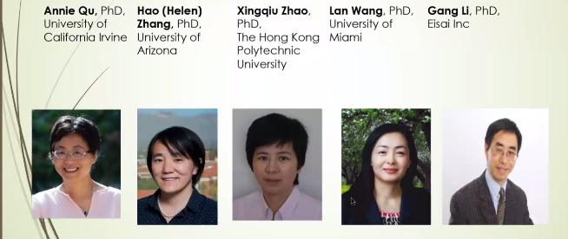

Dr. Tony Sun as a Prestigious Curator’s Distinguished Professor in University of Missouri
Congratulations to Dr. Tony (Jianguo) Sun, ICSA president 2020, on being named as one of the nine University of Missouri faculty members Curator’s Distinguished Professors. A Curators' Distinguished Professorship is the highest and most prestigious academic rank awarded by the Board of Curators. It is awarded to a select few outstanding scholars with established reputations.

ICSA Awards

Distinguished Achievement Award
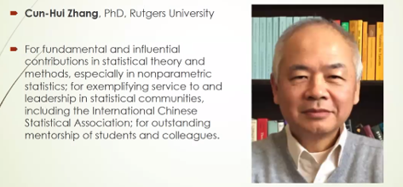

Outstanding Service Awards
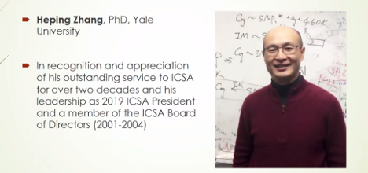

Outstanding Young Research Awards
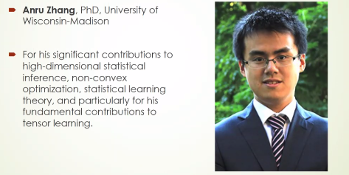
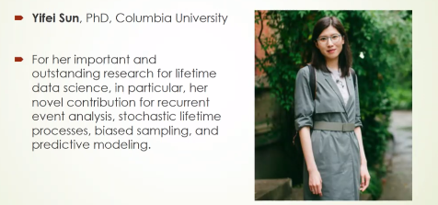

2022 Pao-Lu Hsu Award
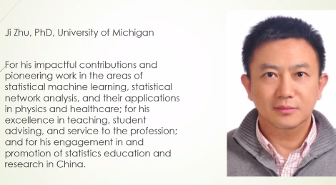

ICSA President Citation
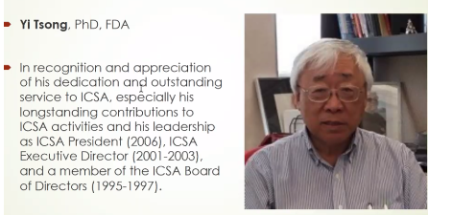

Significant Contribution Awards
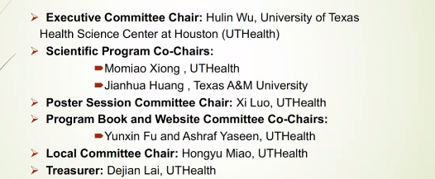
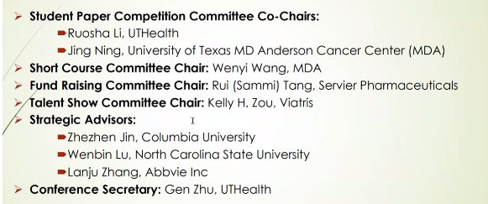

ICSA 2021 Applied Statistics Symposium Student Awards
This symposium was successfully launched from September 12 to September 15, 2021 virtually.

Jiann-Ping Hsu Pharmaceutical and Regulatory Sciences Student Paper Award
Bing Li, Ph.D student, Department of Biostatistics, Brown University.

Student Paper Award
Yujia Deng, Ph.D student, Department of Statistics, University of Illinois Urbana Champaign
Subhankar Bhadra, Ph.D student, Department of Statistics, North Carolina State University
Ying Zhou, Ph.D Student, Department of Statistical Sciences, University of Toronto
Rui Miao, Ph.D Student, Department of Statistics, George Washington University
Ziyan Yin, Ph.D Student, Department of Statistical Science, Temple University

Poster Award
Yang Ou, Yu Xia, Shunyan Luo, Juntao Su, Lanqiu Yao, Joshua Loyal, Nan Miles XI

ICSA Springer Book Series in Statistics
The editor of ICSA Springer book series in statistics, Dr. Din Chen, has reported that there are 22 books in the series now. If you plan to write books in the series, please contact Dr. Din Chen (dinchen@email.unc.edu). The following 2 books were published in 2020:
- Sampling Theory and Practice. (Editors: C. Wu, M.E. Thompson)
- Statistical Methods for Global Health and Epidemiology. (Editors: X. Chen, D-G. Chen)

The following 2 books were published in 2019:
- Contemporary Biostatistics with Biopharmaceutical Applications. (Editors: L. Zhang, D.D.-G. Chen, H. Jiang, G. Li, H. Quan)
- Statistical Quality Technologies (Editors: Y., Lio, H.K.T., Ng, T.-R. Tsai, D-G. Chen)

Refer to this site for all other books’ information.

Sponsored and Co-Sponsored Journals

ICSA Sponsored Journals

Statistica Sinica
Forthcoming papers' information is available at http://www3.stat.sinica.edu.tw/statistica/. The new issue (Volume 31, Number 4, 2021) is published.
ICSA members have access to these articles via the "membership only area" at http://www.icsa.org. If you have any problems with subscription, please contact the editorial office through ss@stat.sinica.edu.tw.

Statistics in Biosciences
The published new issue is Volume 13 Issue 2 in July 2021
Statistics in Biosciences | Volume 13, issue 2 (springer.com)
Recently accepted articles can be found at the journal website
https://link.springer.com/journal/12561/onlineFirst/page/1
A link for submitting your article to SIBS online is below
https://www.editorialmanager.com/sibs/default.aspx

ICSA Co-sponsored Journal

Statistics and Its Interface (SII)
Statistics and Its Interface is an international statistical journal promoting the interface between statistics and other disciplines including, but not limited to, biomedical science, geosciences, computer sciences, engineering, and social and behavioral sciences. The journal publishes high-quality articles in broad areas of statistical science, emphasizing substantive problems, sound statistical models and methods, clear and efficient computational algorithms, and insightful discussions of the motivating problems. Visit SII's web page at http://intlpress.com/site/pub/pages/journals/items/sii/_home/_main/ for more information on the most recent issue (Volume 15 (2022), Number 1).
International Press and Tsinghua University Mathematical Science Center are pleased to announce open online access (free of charge) to the journal Statistics and Its Interface (SII) which includes thirteen volumes.

Upcoming ICSA Meetings
Please find below a list of upcoming ICSA meetings. This list also appears on the ICSA website. Meetings not included in this list are not official ICSA meetings. If you have any questions, please contact Dr. Mengling Liu, the ICSA Executive Director
(executive.director@icsa.org).

ICSA 2022 Applied Statistics Symposium (June 19-22, 2022)
The ICSA 2022 Applied Statistics Symposium will be held at University of Florida, Gainesville, FL on June 19 - 22, 2022. The theme of the symposium is Statistical Innovation in the Era of Artificial Intelligence and Data Science. Keynote speakers are Drs. Susan Murphy (Harvard), David Siegmund (Stanford), and Jianqing Fan (Princeton). For information, please contact the Chair of Organizing committee, Professor Samuel Wu (samwu@biostat.ufl.edu).

ICSA 2022 China Conference (July 1 - 4, 2022)
The ICSA 2022 China Conference will be held at Xi'an University of Finance and Economics, Xian, China, and the date will be announced later. For information, please contact Scientific Program Committee Co-Chairs Professor Yingying Fan at fanyingy@marshall.usc.edu and Professor Chunjie Wang at wangchunjie@ccut.edu.cn.

ICSA 2023 China Conference
The ICSA 2023 China Conference will be held at Chengdu, co-sponsored by Southwest Jiaotong University (SWJTU).

The 12th ICSA International Conference (December 18 – 20, 2022)
The 12th ICSA International Conference will be held at the Chinese University of Hong Kong, Hong Kong, from December 18 to December 20, 2022. For information, please contact Scientific Program Committee Chair Professor (Tony) Jianguo Sun at sunj@missouri.edu or Co-Chair Professor Xingqiu Zhao at Xingqiu.Zhao@polyu.edu.hk.

Upcoming Co-Sponsored Meetings
Please find below a list of upcoming ICSA co-sponsored meetings. This list also appears on the ICSA website. Meetings not included in this list are not officially co-sponsored meetings. If you have any questions, please contact Dr. Mengling Liu, the ICSA Executive Director (executive.director@icsa.org).

77th Annual Deming Conference on Applied Statistics (December 6 – 8, 2021)
The 77th Annual Deming Conference on Applied Statistics will be held from Monday Dec. 6 to Wednesday Dec. 8, 2021, followed by two parallel 2-day short courses on Thursday Dec. 9 and Friday Dec. 10 at the state-of-the-art Tropicana Casino and Resort, Havana Tower, Atlantic City, NJ.

The purpose of the 3-day Deming Conference on Applied Statistics is to provide a learning experience on recent developments in statistical methodologies in biopharmaceutical applications. The conference is composed of twelve three-hour tutorials on current topics in applied biopharmaceutical statistic and FDA regulations, and a one-hour distinguished keynote speaker on each of the 3 days of the conference. The books, on which these sessions are based, are available for sale at an approximately 40% discount. Attendees will receive hard copy program proceedings of the presentations.

There will be poster sessions. Early registrants who submit a poster presentation will receive a $150 discount. For poster submission, please contact “Deming Poster Chair”: Dr. Pinggao Zhang at email: pinggao.zhang@takeda.com.

There will be student scholar presentations. For a student scholar application, please contact “Deming Scholar Chair”: Dr. Sofia Paul at email: sofia.x.paul@gsk.com.

The conference is sponsored by the American Statistical Association Biopharmaceutical Section and the International Chinese Statistical Association. Walter Young has chaired this conference for 52 consecutive years. The program committee include: Alfred Balch, Joseph Borden, Ivan Chan, (Din) Ding-Geng Chen, Kalyan Ghosh, Satish Laroia, Sofia Paul, Manoj Patel, Naitee Ting, Bill Wang, Wenjin Wang, Yibin Wang, Li-an Xu, Walter Young and Pinggao Zhang.

Registration is expected to open by mid-August and one page program should be available by that time. For more information about the conference, please visit https://demingconference.org/ or email Din Chen, Deming Publicity Chair, at din@demingconference.org.

The 8th Workshop on Biostatistics and Bioinformatics (Postponed to Spring, 2022)
Biostatistics and Bioinformatics have been playing key and important roles in statistics and other scientific research fields in recent years. The goal of the 8th workshop is to stimulate research and to foster the interaction of researchers in Biostatistics & Bioinformatics research areas. The workshop will provide the opportunity for faculty and graduate students to meet the top researchers, identify important directions for future research, facilitate research collaborations. The workshop will be held at Atlanta, GA.
A keynote speaker is Dr. Nilanjan Chatterjee, Bloomberg Distinguished Professor of Biostatistics and Medicine at the Johns Hopkins University.
For detailed information including registration, please refer to https://math.gsu.edu/yichuan/2022Workshop/

IMS Asia Pacific Rim Meeting (Postponed to January, 2023)
The sixth meeting of the Institute of Mathematical Statistics Asia Pacific Rim Meeting (IMS-APRM) will provide an excellent worldwide forum for scientific communications and collaborations for researchers in Asia and the Pacific Rim, and promote collaborations between researchers in this area and other parts of the world. The meeting will be held in Melbourne, Australia and please see http://ims-aprm2021.com/ for details. Firm dates will be announced at a later date.

Online Training and Seminars

ICSA Online Training
Online training serves as a viable alternative to traditional continuing education options, e.g., to short courses offered at biostatistical conferences. Over the past year, the ASA Biopharmaceutical Section has been working on creating an online training program aimed at clinical trial statisticians and set up a pilot program, which includes half-day and full-day courses on key topics in biopharmaceutical statistics:
Analysis of Longitudinal and Incomplete Data
Multiplicity Issues in Clinical Trials
Analysis of Surrogate Endpoints in Clinical Trials
The section has received much positive feedback from industry and academic statisticians. Clinical trial statisticians who took advantage of the online training program emphasized that this program is convenient, inexpensive and quite flexible.

A similar online training program has been set up for ICSA members. As a member of the ICSA, you will receive a 50% discount when you sign up for any course included in the program. The online training courses are based on professionally recorded videos using a format similar to that used in YouTube videos. The videos can be accessed 24/7 on a computer or even on a smartphone. The cost of online training is low compared to traditional training, and it can be further reduced by using a group-training format. Up to 25 people can view an online training course with a single registration, which lowers the cost of online training to about $20-25 per person for full-day courses and $10-15 per person for half-day courses.
For more information about the online training program and to sign up for the individual online courses, please visit this web page:
http://sprmm.com/icsa/

Healthcare Innovation Technology: The Pod of Asclepius
Looking to stay up to date on developments in health care technology around the world? The American Statistical Association is sponsoring “The Pod of Asclepius”, a new podcast where data scientists, statisticians, engineers, and regulatory experts discuss the technical challenges in their healthcare domain.

We have over 20 episodes published and available on YouTube, Podbean, iTunes, Stitcher, Podchaser, Tune In Radio, and Google Play.

Looking for a good place to start? Check out the following episode links:
- Risks and Opportunities of AI in Clinical Drug Development with David Madigan and Demissie Alemayehu
- Kidney Injury - Biomarkers for Prediction and Prognosis with Allison Meisner
- NHS Digital Health Initiatives with Emma Hughes
- Data Platforms to Monitor Animal Health with Shane Burns
- Bayesian Approaches in Medical Devices: Part 1, Part 2, Part 3 with Martin Ho and Greg Maislin

You can catch up on all episodes on our YouTube playlists for Season 0 and Season 1.

The easiest way to catch new episodes is to subscribe via our channels….
Youtube: https://www.youtube.com/channel/UCkEz2tDR5K6AjlKw-JrV57w
Podbean: https://podofasclepius.podbean.com
You can see our full schedule on the website: www.podofasclepius.com

Fall Series: The Philosophy of Data Science
The series is aimed at incoming statistics and data science students (but will be of significant interest to the general statistics / data science community). The topics will focus on how scientific reasoning is essential to the practice of data science.

For detailed information, please visit: https://www.podofasclepius.com/philosophy-of-data-science.

Job Listings

Research Assistant Professor in Applied Statistics and Financial Mathematics / Engineering and Computational Mathematics / Applied Optimization and Operations Research (three posts) (Ref. 21080613)
Department of Applied Mathematics
The Hong Kong Polytechnic University
The Department of Applied Mathematics (AMA) is part of the Faculty of Applied Science and Textiles. The Department offers undergraduate programmes in Investment Science and Finance Analytics, and Data Science and Analytics, and makes a significant contribution to most of other academic programmes of the University by providing service teaching. It also offers master programmes in Applied Mathematics for Science and Technology with specialisms in Decision Science and Actuarial Science, and Operational Research and Risk Analysis. Members of the Department have expertise in applied optimization and optimal control, engineering computation, operational research, management science and applied statistics. There are currently 39 academic staff and about 70 research personnel in the Department. Please visit the website at http://www.polyu.edu.hk/ama for more information about the Department.
The Department has established a Joint Laboratory of Applied Mathematics with the Academy of Mathematics and Systems Science of the Chinese Academy of Sciences. The appointees are expected to be actively involved in the activities of the Laboratory.
Duties
The appointees will be required to:
(a) conduct research as the main duty and actively pursue external research grants, such as General Research Fund, as Principal Investigator or Co-Investigator;
(b) provide quality teaching at undergraduate or postgraduate level;
(c) contribute to departmental service; and
(d) perform any other duties as assigned by the Head of Department or his/her delegates.
Qualifications
Applicants should:
(a) have a doctoral degree in Mathematics / Statistics / Financial Mathematics / Operations Research / Computational Mathematics / Applied Mathematics or a closely related field;
(b) have demonstrated promise of a high level of creativity in research and teaching in some subdivisions of his/her field;
(c) be able to demonstrate effective classroom teaching; and
(d) be highly proficient in written and spoken English.
Remuneration and Conditions of Service
A highly competitive package including a medical benefits plan and a gratuity payable upon completion of the term which is normally for three years initially, with possibility of extension for another three years. Applicants should state their current and expected salary in the application.
Application
Please send a completed application form by post, providing the names and addresses of three referees, to Human Resources Office, 13/F, Li Ka Shing Tower, The Hong Kong Polytechnic University, Hung Hom, Kowloon, Hong Kong or via email to hrstaff@polyu.edu.hk. Application forms can be downloaded from http://www.polyu.edu.hk/hro/job/en/guide_forms/forms.php. If a separate curriculum vitae is to be provided, please still complete the application form which will help speed up the recruitment process. Consideration of applications will commence on 27 August 2021 until the positions are filled. The University’s Personal Information Collection Statement for recruitment can be found at http://www.polyu.edu.hk/hro/job/en/guide_forms/pics.php.
PolyU is an equal opportunity employer committed to diversity and inclusivity. All qualified applicants will receive consideration for employment without regard to gender, ethnicity, nationality, family status or physical or mental disabilities.

Tenure-Track Faculty Positions, The Institute of Statistical Science of Academia Sinica, Academia Sinica, Taiwan
The Institute of Statistical Science of Academia Sinica is pleased to invite applications for our tenure-track faculty positions. Academia Sinica, the most preeminent academic research institution in Taiwan, offers a secured research environment facilitated with rich collaboration opportunities as well as the freedom of conducting independent research. With a strong tradition of theoretical and interdisciplinary research, the Institute of Statistical Science is aiming for global excellence in mathematical statistics and various statistical applications.
Applications are invited for tenure-track appointments as Full/Associate/ Assistant Research Fellows (equivalent to Full/Associate/Assistant Professors in Universities) at the Institute of Statistical Science to commence on August 1, 2022 or as soon as possible thereafter. Applicants should possess a Ph.D. degree in Statistics, Biostatistics, Computer Science, Data Science or related areas, and should submit: (1) a cover letter, (2) an up-to-date curriculum vita, (3) a detailed publication list, (4) a research proposal, (5) three letters of recommendation, (6) representative publications and/or technical reports and (7) advisers’ names of master and PhD degrees. Additional supporting materials such as transcripts for new Ph.D. degree recipients may also be included. Electronic submissions are encouraged. Applications should be submitted to
Dr. I-Ping Tu
Chair of the Search Committee
Institute of Statistical Science, Academia Sinica
128 Sec. 2 Academia Road, Taipei 11529, Taiwan, R.O.C.
Fax: +886-2-27886833
E-mail: recruit@stat.sinica.edu.tw
Application materials should be received by December 31, 2021 for consideration, but early submissions are encouraged.

Electronic ICSA News Access
Please visit https://www.icsa.org/publications/icsa-member-newsletter-archive/ for all ICSA member news online.

