ICSA Member News June 2021
Highlights 3
Candidates for ICSA 2022 ICSA President-Elect 3
Candidates for ICSA 2022 Board of Directors 3
Congratulations to the ICSA Members on Being Elected as the Prestigious ASA and IMS Fellows 5
2020 ASA Fellow 5
2021 ASA Fellow 6
2020 IMS Fellow 7
2021 IMS Fellow 7
ICSA 2021 Applied Statistics Symposium (September 12-15, 2021) 9
12th ICSA International Conference (December 18 – 20, 2022) 10
Sponsored and Co-Sponsored Journals 11
ICSA Sponsored Journals 11
Statistica Sinica 11
Statistics in Biosciences 11
ICSA Co-sponsored Journal 12
Statistics and Its Interface (SII) 12
Upcoming ICSA Meetings 12
ICSA 2021 Applied Statistics Symposium (September 12 - 15, 2021) 12
ICSA 2022 Applied Statistics Symposium 12
ICSA 2021 China Conference Postponed to 2022 13
ICSA 2022 China Conference (July 1 - 4, 2022) 13
ICSA 2023 China Conference 13
12th ICSA International Conference (December 18 – 20, 2022) 13
Upcoming Co-Sponsored Meetings 14
The 63rd ISI World Statistics Congress 2021 (July 11 - 16, 2021) 14
China Biostatistics Summit (July 16 – 18, 2021) 14
77th Annual Deming Conference on Applied Statistics (December 6 – 8, 2021) 14
The 8th Workshop on Biostatistics and Bioinformatics (Postponed to Spring, 2022) 15
IMS Asia Pacific Rim Meeting (Postponed to January, 2023) 16
Online Training and Seminars 16
ICSA Online Training 16
ASA Podcasts: ICSA Leadership Panel 17
Healthcare Innovation Technology: The Pod of Asclepius 17
Job Listings 18
Electronic ICSA News Access 18

Highlights

Candidates for ICSA 2022 ICSA President-Elect
Dr. Hongzhe Lee
Professor
Biostatistics and
Statistics
Vice Chair of Research
Integration
Director, Center for
Statistics in Big Data
University of Pennsylvania

Dr. Gang Li
Professor
Departments of Biostatistics
& Computational
Medicine
Director, UCLA's Jonsson
Comprehensive Cancer
Center Biostatistics University of California, Los Angeles

Candidates for ICSA 2022 Board of Directors
Please visit https://www.icsa.org/bd-nominees-combined_final/ and click each candidate’s name for more information. Your vote is important. The general election voting will open on July 6th and end on July 31st, 2021. Please cast your vote.
Eligible ICSA regular members receive further details via e-mail prior to the start of elections, including a summary of the candidates, details on how to access the voting system. Please ensure the Membership Committee has your recent and correct e-mail address on file. For questions, you can reach the Membership Committee in private at membership@icsa.org.

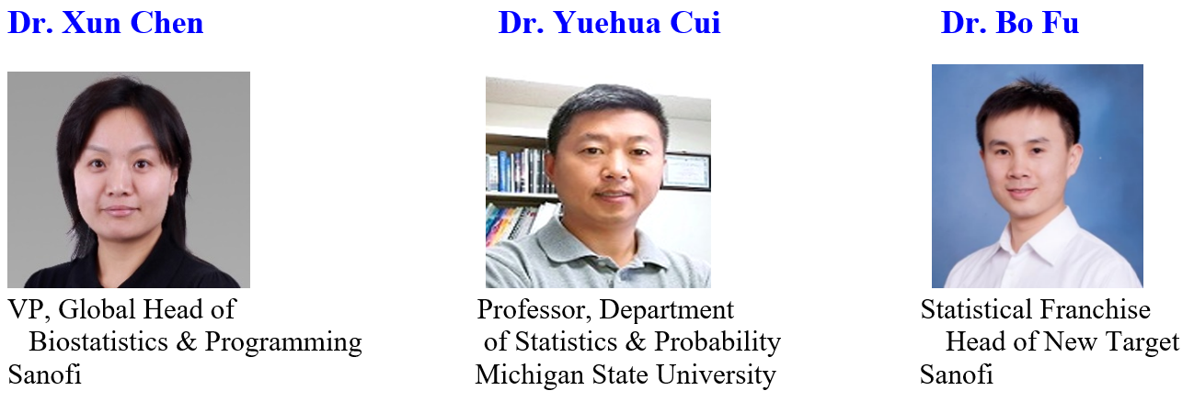

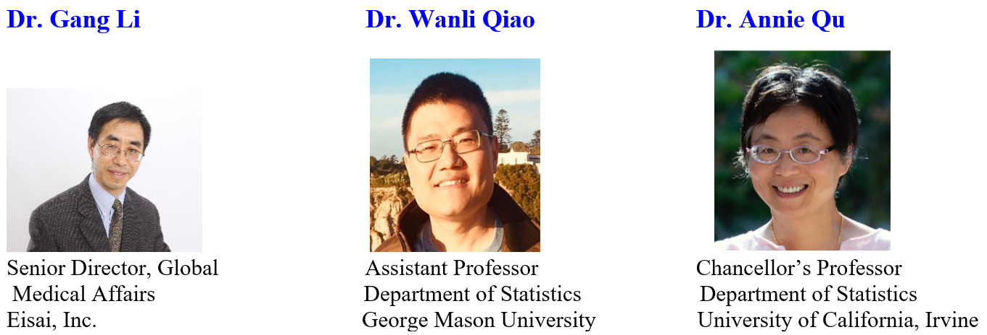

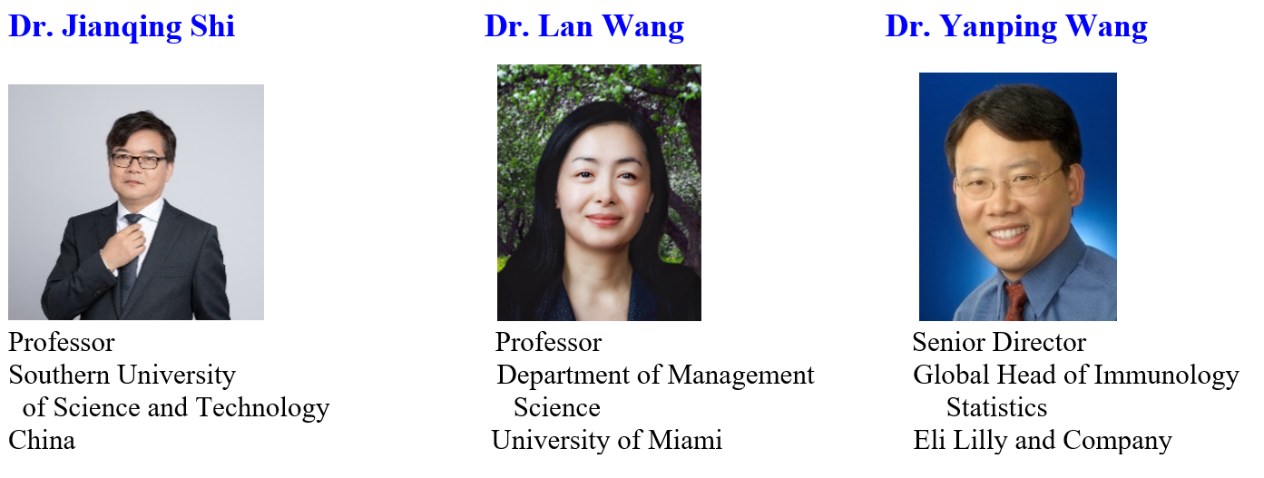

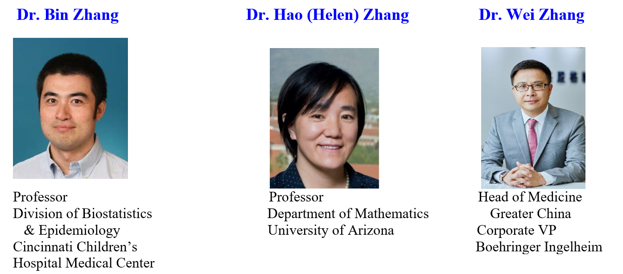
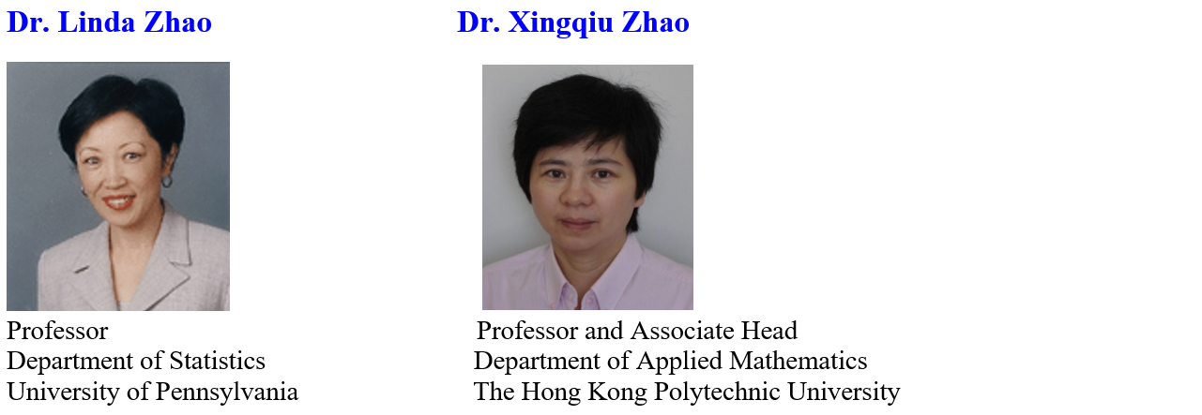

Congratulations to the ICSA Members on Being Elected as the Prestigious ASA and IMS Fellows

2020 ASA Fellow
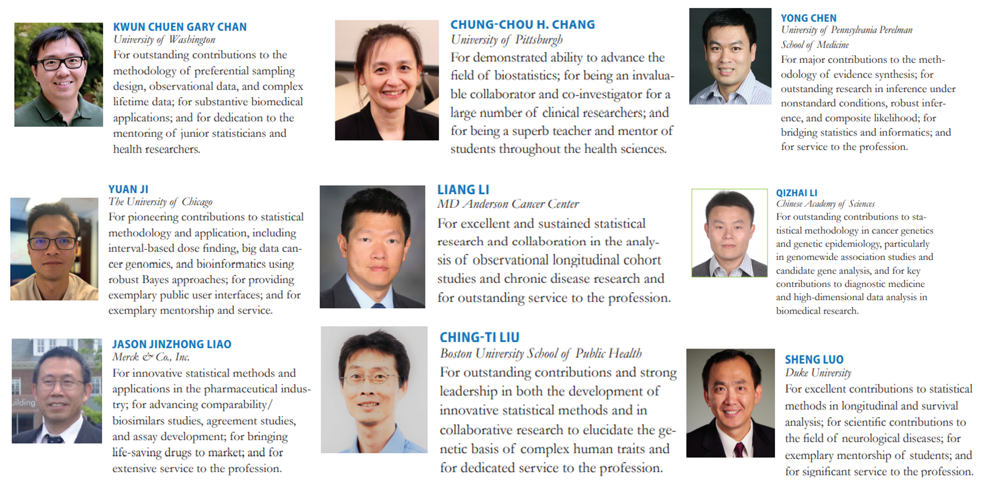
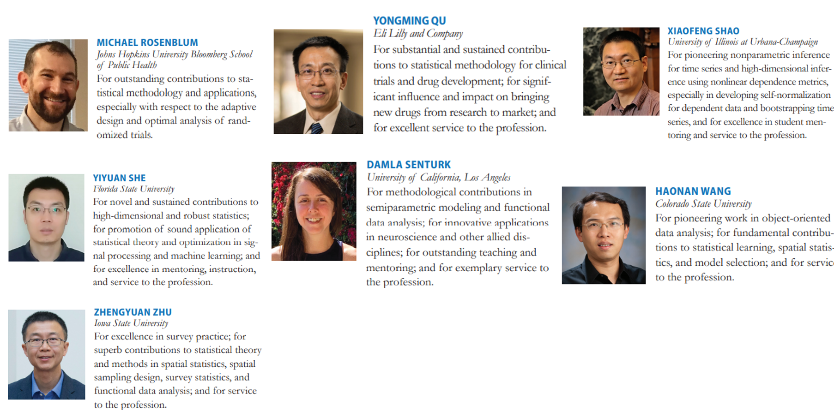

2021 ASA Fellow
Thomas M. Braun, Ph.D, Professor of Biostatics, School of Public Health, University of Michigan
Jie Chen, Ph.D, Sr. VP, Head of Biometric, Overland Pharmaceuticals
Zhen Chen, Ph.D, Sr. Investigator, NICHD’s Biostatistics and Bioinformatics Branch, NIH
Li-Shan Huang, Ph.D, Professor, Institute of Statistics, National Tsing Hua University
Yan Li, Ph.D. Professor, Epidemiology and Biostatistics, University of Maryland
Fang Liu, Ph.D, Professor, Department of Applied and Computational Mathematics and Statistics, University of Notre Dame
Bo Lu, Ph.D, Professor, Division of Biostatistics, The Ohio State University
Weiwen Miao, Ph.D, Professor, Department of Mathematics and Statistics, Haverford College
David Ian Ohlssen, Ph.D, Head of Advanced Exploratory Analytics at Novartis
Kimberly F. Sellers, Ph.D, Professor, Department of Mathematics and Statistics, Georgetown University
Rui Song, Ph.D, Professor, Department of Statistics, North Carolina State University
Lilly Wang, Ph.D, Professor, Department of Statistics, Iowa State University
Xiao Wang, Ph.D, Professor, Department of Statistics, Purdue University
Xiaofei Wang, Ph.D, Professor, Department of Biostatics and Bioinformatics, Duke University
Hongquan Xu, Ph.D, Professor and Chair, Department of Statistics, University of California, Los Angeles
Yichuan Zhao, Ph.D, Prof., Department of Mathematics and Statistics, Georgia State University

2020 IMS Fellow
Guang Cheng, Purdue University: For outstanding work in methodology and theory of statistics, especially in high dimensional data, semiparametric estimation and inference, big data, and machine learning.
Chenlei Leng, University of Warwick: For fundamental contributions to the theory and practice of high-dimensional statistics, statistical machine learning, model selection, and network data analysis.
Wei Pan, University of Minnesota: For his important contributions to survival analysis, correlated data analysis, statistical learning, bioinformatics, and applications to biology and medicine, and for his dedicated services to the profession.
Lily Wang, Iowa State University: For contributions to spatial, survey, image and functional analysis using nonparametric and semiparametric methods, especially to partially linear models, confidence envelopes and bivariate smoothing.
Grace Y. Yi, University of Western Ontario: For research excellence in developing theory and methods for the analysis of survival data and longitudinal data in statistical and biostatistical applications, and for world-leading contributions to the analysis of missing and mismeasured data.
Li-Xin Zhang, Zhejiang University: For important contributions to difficult problems in probability and statistical inference; and for excellence in mentoring and services.

2021 IMS Fellow
Kwun Chuen Gary Chan, University of Washington
For outstanding contributions to the methodology of preferential sampling design, observational data, and complex lifetime data; for substantive leadership in the application of statistics in public health and biomedical research.
Scott H. Holan, University of Missouri
For significant research contributions to time series, spatial statistics, spatio-temporal modeling, for applications to official statistics, and for his dedicated service to the statistics profession.
Jian Huang, University of Iowa
For fundamental contributions to high-dimensional statistics, survival analysis, and statistical genetics and genomics.
Jing Lei, Carnegie Mellon University
For fundamental and innovative contributions to sparse Principal Component Analysis, conformal prediction, network analysis, and spectral methods, optimal transport, cross-validation, and differential privacy, as well as applied work on the analysis of tissue and single-cell RNA sequencing data and autism.
Lexin Li, University of California, Berkeley
For influential contributions to sufficient dimension reduction, tensor regression, and neuroimaging applications, and for outstanding service to the profession.
Huazhen Lin, Southwestern University of Finance and Economics
For outstanding contributions to theory and methods for survival analysis and semiparametric/nonparametric modeling; for dedicated service to the profession; and for strong leadership in statistics education and development in China.
Steven MacEachern, The Ohio State University
For fundamental and influential contributions to Bayesian statistics and inference, especially in the area of Bayesian nonparametrics, for dedicated mentoring of students and young researchers, and service to the profession.
Marianthi Markatou, University at Buffalo
For outstanding accomplishments on fundamental research in robust statistics and for a strong commitment to the advancement of statistical science through interdisciplinary research and professional service.
Yiyuan She, Florida State University
For novel and sustained contributions to high dimensional and robust statistics, for excellence in mentoring, instruction, and service to the profession.
Peter Xuekun Song, University of Michigan
For pathbreaking developments in likelihood inference, for outstanding contribution in medical research, and for exceptional service and mentorship.
Rui Song, North Carolina State University
For significant contributions to machine learning methods, dynamic treatment regime, and efficient and non-standard statistical inference.
Zhiqiang Tan, Rutgers, The State University of New Jersey
For seminal contributions to statistical theory and practice, including Monte Carlo sampling and causal inference, to significant contributions in collaborative research, and for contributions to the profession, including via editorial and organizational efforts.
Nian-Sheng Tang, Yunnan University
For excellent research accomplishments on statistical inference with missing data and distinguished contributions to the promotion of statistics in developing regions.
Xiao Wang, Purdue University
For significant contributions to nonparametric statistics, shape-restricted inference, and functional data analysis, and for dedicated professional service and students’ mentoring.
Changbao Wu, University of Waterloo
For important and original research contributions to survey sampling theory and official statistics, especially for the development of model-calibration theory and techniques, empirical likelihood methods for complex surveys, and robust inferential procedures for analyzing non-probability samples.
Min-ge Xie, Rutgers, The State University of New Jersey
For outstanding contributions to statistical research especially confidence distributions, fusion learning, meta-analysis, estimating equations, and statistical applications in biomedical sciences, industry, engineering, and environmental science. For exemplary service to the profession and university.
Zhengjun Zhang, University of Wisconsin–Madison
For significant contributions to extreme value statistics and risk management, including tail dependence measure and nonlinear dependence measure construction and inference, max-linear competing factor models, nonlinear time series models for high-frequency financial data; and for conscientious editorial and other services to the profession.
Yijun Zuo, Michigan State University
For pioneering and path-breaking contributions to the area of data depth, theory and methodology, and its applications.

ICSA 2021 Applied Statistics Symposium (September 12-15, 2021)
The ICSA Applied Statistics Symposium will be held virtually from Sunday, September 12, to Wednesday, September 15, 2021. The theme of this year’s conference is Leading with Statistics and Innovation. We hope that this meeting will attract statisticians working in academia, government, and industry; domestic and international statisticians. The 2021 symposium will offer short courses, invited sessions and poster presentations, as well as opportunities for networking and recruiting. The deadline for early bird registration, invited session abstract, and poster session abstract submission is July 15, 2021.

Please send any inquiry to Dr. Guoqing Diao (gdiao@gwu.edu). Please visit https://symposium2021.icsa.org/ for details, including the key dates.

Executive Committee
      - Executive Committee Chair: Guoqing Diao (George Washington University)
      - Scientific Program Chairs: Judy Wang and Qing Pan (George Washington University)
      - Poster Session Committee Chair: Fang Jin
      - Program Book and Website Committee Chair: Scott Bruce (George Mason University)
      - Local Committee Chair: Zhen Chen (National Institutes of Health)
      - Treasurer: Xin He (University of Maryland, College Park)
      - Student Paper Competition Committee Chair: Lu Mao (University of Wisconsin, Madison)
      - Short Course Committee Chair: Yan Ma (George Washington University)
      - Fund Raising Committee Chair: Li Wang (Abbvie)
      - Strategic Advisors: Hulin Wu (University of Texas Health Science Center at Houston) and Aiyi Liu (National Institutes of Health)
Dr. Guoqing Diao at The George Washington University (gdiao@gwu.edu) chairs the Organization Committee.

12th ICSA International Conference (December 18 – 20, 2022)
The 12th ICSA International Conference will be held at the Chinese University of Hong Kong, Hong Kong, from December 18 to December 20, 2022. For information, please contact Scientific Program Committee Chair Professor (Tony) Jianguo Sun at sunj@missouri.edu or Co-Chair Professor Xingqiu Zhao at Xingqiu.Zhao@polyu.edu.uk.

ICSA Springer Book Series in Statistics
The editor of ICSA Springer book series in statistics, Dr. Din Chen, has reported that there are 22 books in the series now. If you plan to write books in the series, please contact Dr. Din Chen (dinchen@email.unc.edu). The following 2 books were published in 2020:
- Sampling Theory and Practice. (Editors: C. Wu, M.E. Thompson)
- Statistical Methods for Global Health and Epidemiology. (Editors: X. Chen, D-G. Chen)

The following 2 books were published in 2019:
- Contemporary Biostatistics with Biopharmaceutical Applications. (Editors: L. Zhang, D.D.-G. Chen, H. Jiang, G. Li, H. Quan)
- Statistical Quality Technologies (Editors: Y., Lio, H.K.T., Ng, T.-R. Tsai, D-G. Chen)

Sponsored and Co-Sponsored Journals

ICSA Sponsored Journals

Statistica Sinica
Forthcoming papers' information is available at http://www3.stat.sinica.edu.tw/statistica/. The new issue (Volume 31, Number 2, 2021) is published.
ICSA members have access to these articles via the "membership only area" at http://www.icsa.org. If you have any problems with subscription, please contact the editorial office through ss@stat.sinica.edu.tw.

Statistics in Biosciences
The published new issue is Volume 13 Issue 2 in July 2021
Statistics in Biosciences | Volume 13, issue 2 (springer.com)
Recently accepted articles can be found at the journal website
https://link.springer.com/journal/12561/onlineFirst/page/1
A link for submitting your article to SIBS online is below
https://www.editorialmanager.com/sibs/default.aspx

ICSA Co-sponsored Journal

Statistics and Its Interface (SII)
Statistics and Its Interface is an international statistical journal promoting the interface between statistics and other disciplines including, but not limited to, biomedical science, geosciences, computer sciences, engineering, and social and behavioral sciences. The journal publishes high-quality articles in broad areas of statistical science, emphasizing substantive problems, sound statistical models and methods, clear and efficient computational algorithms, and insightful discussions of the motivating problems. Visit SII's web page at http://intlpress.com/site/pub/pages/journals/items/sii/_home/_main/ for more information on the most recent issue (Volume 14 (2021), Number 3).
International Press and Tsinghua University Mathematical Science Center are pleased to announce open online access (free of charge) to the journal Statistics and Its Interface (SII) which includes thirteen volumes.

Upcoming ICSA Meetings
Please find below a list of upcoming ICSA meetings. This list also appears on the ICSA website. Meetings not included in this list are not official ICSA meetings. If you have any questions, please contact Dr. Mengling Liu, the ICSA Executive Director
(executive.director@icsa.org).

ICSA 2021 Applied Statistics Symposium (September 12 - 15, 2021)
The 2021 ICSA Applied Statistics Symposium will be held virtually on September 12-15, 2021. For detailed information, please click this link.

ICSA 2022 Applied Statistics Symposium
The 2022 ICSA Applied Statistics Symposium will be held in Gainesville, Florida. More detailed information will be shared later.

ICSA 2021 China Conference Postponed to 2022
The ICSA 2021 China Conference is postponed to 2022 and will be held at Xi'an University of Finance and Economics, Xian, China.

ICSA 2022 China Conference (July 1 - 4, 2022)
The ICSA 2022 China Conference will be held at Xi'an University of Finance and Economics, Xian, China, and the date will be announced later. For information, please contact Scientific Program Committee Co-Chairs Professor Yingying Fan at fanyingy@marshall.usc.edu and Professor Chunjie Wang at wangchunjie@ccut.edu.cn.

ICSA 2023 China Conference
The ICSA 2023 China Conference will be held at Chengdu, co-sponsored by Southwest Jiaotong University (SWJTU).

12th ICSA International Conference (December 18 – 20, 2022)
The 12th ICSA International Conference will be held at the Chinese University of Hong Kong, Hong Kong, from December 18 to December 20, 2022. For information, please contact Scientific Program Committee Chair Professor (Tony) Jianguo Sun at sunj@missouri.edu or Co-Chair Professor Xingqiu Zhao at Xingqiu.Zhao@polyu.edu.uk.

Call for Invited Session Proposals
The conference scientific program committee welcomes invited session proposals. An invited session consists of either 4 presenters or 3 presenters plus 1 discussant. The one-talk rule will be applied (i.e., each speaker can only give one invited talk). It is required to confirm all speakers’ availability before the proposal submission. Please send your proposal to the Chair or Co-Chair mentioned above before September 19, 2021. The acceptance of invited sessions will be determined by December 1, 2021. In order to secure the invited session slot, the presenters will be required to register to the conference and submit the abstracts online by a deadline to be given later.

Upcoming Co-Sponsored Meetings
Please find below a list of upcoming ICSA co-sponsored meetings. This list also appears on the ICSA website. Meetings not included in this list are not officially co-sponsored meetings. If you have any questions, please contact Dr. Mengling Liu, the ICSA Executive Director (executive.director@icsa.org).

The 63rd ISI World Statistics Congress 2021 (July 11 - 16, 2021)
The World Statistics Congress 2021 will be held virtually in July 2021. More information can be found on the ISI 2021 website www.isi2021.org.

China Biostatistics Summit (July 16 – 18, 2021)
China Biostatistics Summit (CBS) is an annual national conference focusing on statistics in drug development and regulatory decision making. This conference is organized by the China Tripartite Coordination Committee (CTCC) which comprises statisticians from government (Center for Drug Evaluation or CDE of the National Medical Product Administration or China’s FDA), academic, and industry. The purposes of the CTCC are to draft new and/or revise existing statistics guidelines for use in the industry and by the regulatory agency. Therefore, the annual conference (similar to the Regulatory-Industry Statistics Workshop or RISW in the US) aims at bringing statisticians working in drug development and regulation to discuss new technical guidelines, share experiences, and learn new methodologies. This year’s CBS (the 4th CBS) will take place in Guangzhou on July 16 – 18, 2021 with the theme of “Practice and Consensus – A Joint Journey for Development and Regulation” (实践与共识 – 研发和监管共发展). As usual, many CDE officers, statisticians, and department heads will be invited to give speeches at this conference. Details can be found here.

77th Annual Deming Conference on Applied Statistics (December 6 – 8, 2021)
The 77th Annual Deming Conference on Applied Statistics will be held from Monday Dec. 6 to Wednesday Dec. 8, 2021, followed by two parallel 2-day short courses on Thursday Dec. 9 and Friday Dec. 10 at the state-of-the-art Tropicana Casino and Resort, Havana Tower, Atlantic City, NJ.

The purpose of the 3-day Deming Conference on Applied Statistics is to provide a learning experience on recent developments in statistical methodologies in biopharmaceutical applications. The conference is composed of twelve three-hour tutorials on current topics in applied biopharmaceutical statistic and FDA regulations, and a one-hour distinguished keynote speaker on each of the 3 days of the conference. The books, on which these sessions are based, are available for sale at an approximately 40% discount. Attendees will receive hard copy program proceedings of the presentations.

There will be poster sessions. Early registrants who submit a poster presentation will receive a $150 discount. For poster submission, please contact “Deming Poster Chair”: Dr. Pinggao Zhang at email: pinggao.zhang@takeda.com.

There will be student scholar presentations. For a student scholar application, please contact “Deming Scholar Chair”: Dr. Sofia Paul at email: sofia.x.paul@gsk.com.

The conference is sponsored by the American Statistical Association Biopharmaceutical Section and the International Chinese Statistical Association. Walter Young has chaired this conference for 52 consecutive years. The program committee include: Alfred Balch, Joseph Borden, Ivan Chan, (Din) Ding-Geng Chen, Kalyan Ghosh, Satish Laroia, Sofia Paul, Manoj Patel, Naitee Ting, Bill Wang, Wenjin Wang, Yibin Wang, Li-an Xu, Walter Young and Pinggao Zhang.

Registration is expected to open by mid-August and one page program should be available by that time. For more information about the conference, please visit https://demingconference.org/ or email Din Chen, Deming Publicity Chair, at din@demingconference.org.

The 8th Workshop on Biostatistics and Bioinformatics (Postponed to Spring, 2022)
Biostatistics and Bioinformatics have been playing key and important roles in statistics and other scientific research fields in recent years. The goal of the 8th workshop is to stimulate research and to foster the interaction of researchers in Biostatistics & Bioinformatics research areas. The workshop will provide the opportunity for faculty and graduate students to meet the top researchers, identify important directions for future research, facilitate research collaborations. The workshop will be held at Atlanta, GA.
A keynote speaker is Dr. Nilanjan Chatterjee, Bloomberg Distinguished Professor of Biostatistics and Medicine at the Johns Hopkins University.
For detailed information including registration, please refer to https://math.gsu.edu/yichuan/2022Workshop/

IMS Asia Pacific Rim Meeting (Postponed to January, 2023)
The sixth meeting of the Institute of Mathematical Statistics Asia Pacific Rim Meeting (IMS-APRM) will provide an excellent worldwide forum for scientific communications and collaborations for researchers in Asia and the Pacific Rim, and promote collaborations between researchers in this area and other parts of the world. The meeting will be held in Melbourne, Australia and please see http://ims-aprm2021.com/ for details. Firm dates will be announced at a later date.

Online Training and Seminars

ICSA Online Training
Online training serves as a viable alternative to traditional continuing education options, e.g., to short courses offered at biostatistical conferences. Over the past year, the ASA Biopharmaceutical Section has been working on creating an online training program aimed at clinical trial statisticians and set up a pilot program, which includes half-day and full-day courses on key topics in biopharmaceutical statistics:
Analysis of Longitudinal and Incomplete Data
Multiplicity Issues in Clinical Trials
Analysis of Surrogate Endpoints in Clinical Trials
The section has received much positive feedback from industry and academic statisticians. Clinical trial statisticians who took advantage of the online training program emphasized that this program is convenient, inexpensive and quite flexible.

A similar online training program has been set up for ICSA members. As a member of the ICSA, you will receive a 50% discount when you sign up for any course included in the program. The online training courses are based on professionally recorded videos using a format similar to that used in YouTube videos. The videos can be accessed 24/7 on a computer or even on a smartphone. The cost of online training is low compared to traditional training, and it can be further reduced by using a group-training format. Up to 25 people can view an online training course with a single registration, which lowers the cost of online training to about $20-25 per person for full-day courses and $10-15 per person for half-day courses.
For more information about the online training program and to sign up for the individual online courses, please visit this web page:
http://sprmm.com/icsa/

ASA Podcasts: ICSA Leadership Panel
Date: June 30, 2021
Description: Haoda Fu, Mengling Liu, Jie Tang, Tian Zheng, and Kelly Zou discuss leadership and the impact of COVID-19 on the workplace.
Please click this link to listen to the episode 90.

Healthcare Innovation Technology: The Pod of Asclepius
Looking to stay up to date on developments in health care technology around the world? The American Statistical Association is sponsoring “The Pod of Asclepius”, a new podcast where data scientists, statisticians, engineers, and regulatory experts discuss the technical challenges in their healthcare domain.

We have over 20 episodes published and available on YouTube, Podbean, iTunes, Stitcher, Podchaser, Tune In Radio, and Google Play.

Looking for a good place to start? Check out the following episode links:
- Risks and Opportunities of AI in Clinical Drug Development with David Madigan and Demissie Alemayehu
- Kidney Injury - Biomarkers for Prediction and Prognosis with Allison Meisner
- NHS Digital Health Initiatives with Emma Hughes
- Data Platforms to Monitor Animal Health with Shane Burns
- Bayesian Approaches in Medical Devices: Part 1, Part 2, Part 3 with Martin Ho and Greg Maislin

You can catch up on all episodes on our YouTube playlists for Season 0 and Season 1.

The easiest way to catch new episodes is to subscribe via our channels….
Youtube: https://www.youtube.com/channel/UCkEz2tDR5K6AjlKw-JrV57w
Podbean: https://podofasclepius.podbean.com
You can see our full schedule on the website: www.podofasclepius.com

Fall Series: The Philosophy of Data Science
The series is aimed at incoming statistics and data science students (but will be of significant interest to the general statistics / data science community). The topics will focus on how scientific reasoning is essential to the practice of data science.

For detailed information, please visit: https://www.podofasclepius.com/philosophy-of-data-science.

Job Listings
N/A

Electronic ICSA News Access
Please visit https://www.icsa.org/publications/icsa-member-newsletter-archive/ for all ICSA member news online.

