ICSA Member News May 2020
Highlights 3
Candidates for ICSA 2021 President Elect 3
Candidates for ICSA 2021 Board of Directors 3
ICSA 2020 Applied Statistics Symposium (Postponed to December 13-16, 2020) 4
2020 NISS Writing Workshop (Virtual) for Junior Researchers (at JSM August 2 & 4, 2020) 5
ICSA Springer Book Series in Statistics 6
Sponsored and Co-Sponsored Journals 7
Statistica Sinica 7
Statistics in Biosciences 7
Statistics and Its Interface (SII) Call for Papers 7
Upcoming ICSA Meetings 9
ICSA 2020 Applied Statistics Symposium (Postponed to December 13-16, 2020) 9
ICSA 2021 China Conference (July 2 – 5, 2021) 9
ICSA 2022 China Conference (July 1 – 4, 2022) 9
Upcoming Co-Sponsored Meetings 10
Duke-Industry Statistics Symposium (August 26 -28, 2020) 10
The 8th Workshop on Biostatistics and Bioinformatics (Tentative Fall, 2020) 10
IMS Asia Pacific Rim Meeting (January 5–8, 2021) 11
Online Training Program 11
Machine Learning Boot Camp: Analyzing Biomedical and Health Data (June 8-9, 2020) 12
Healthcare Innovation Technology: The Pod of Asclepius 13
Job Listings 13
Founding Faculty in the Information Hub (Data Science and Analytics (DSA) 14
Electronic ICSA News Access 16

Highlights

Candidates for ICSA 2021 President Elect

Dr. Yazhen Wang
Professor of Statistics, Department of Statistics, University of Wisconsin-Madison

Dr. Zhezhen Jin
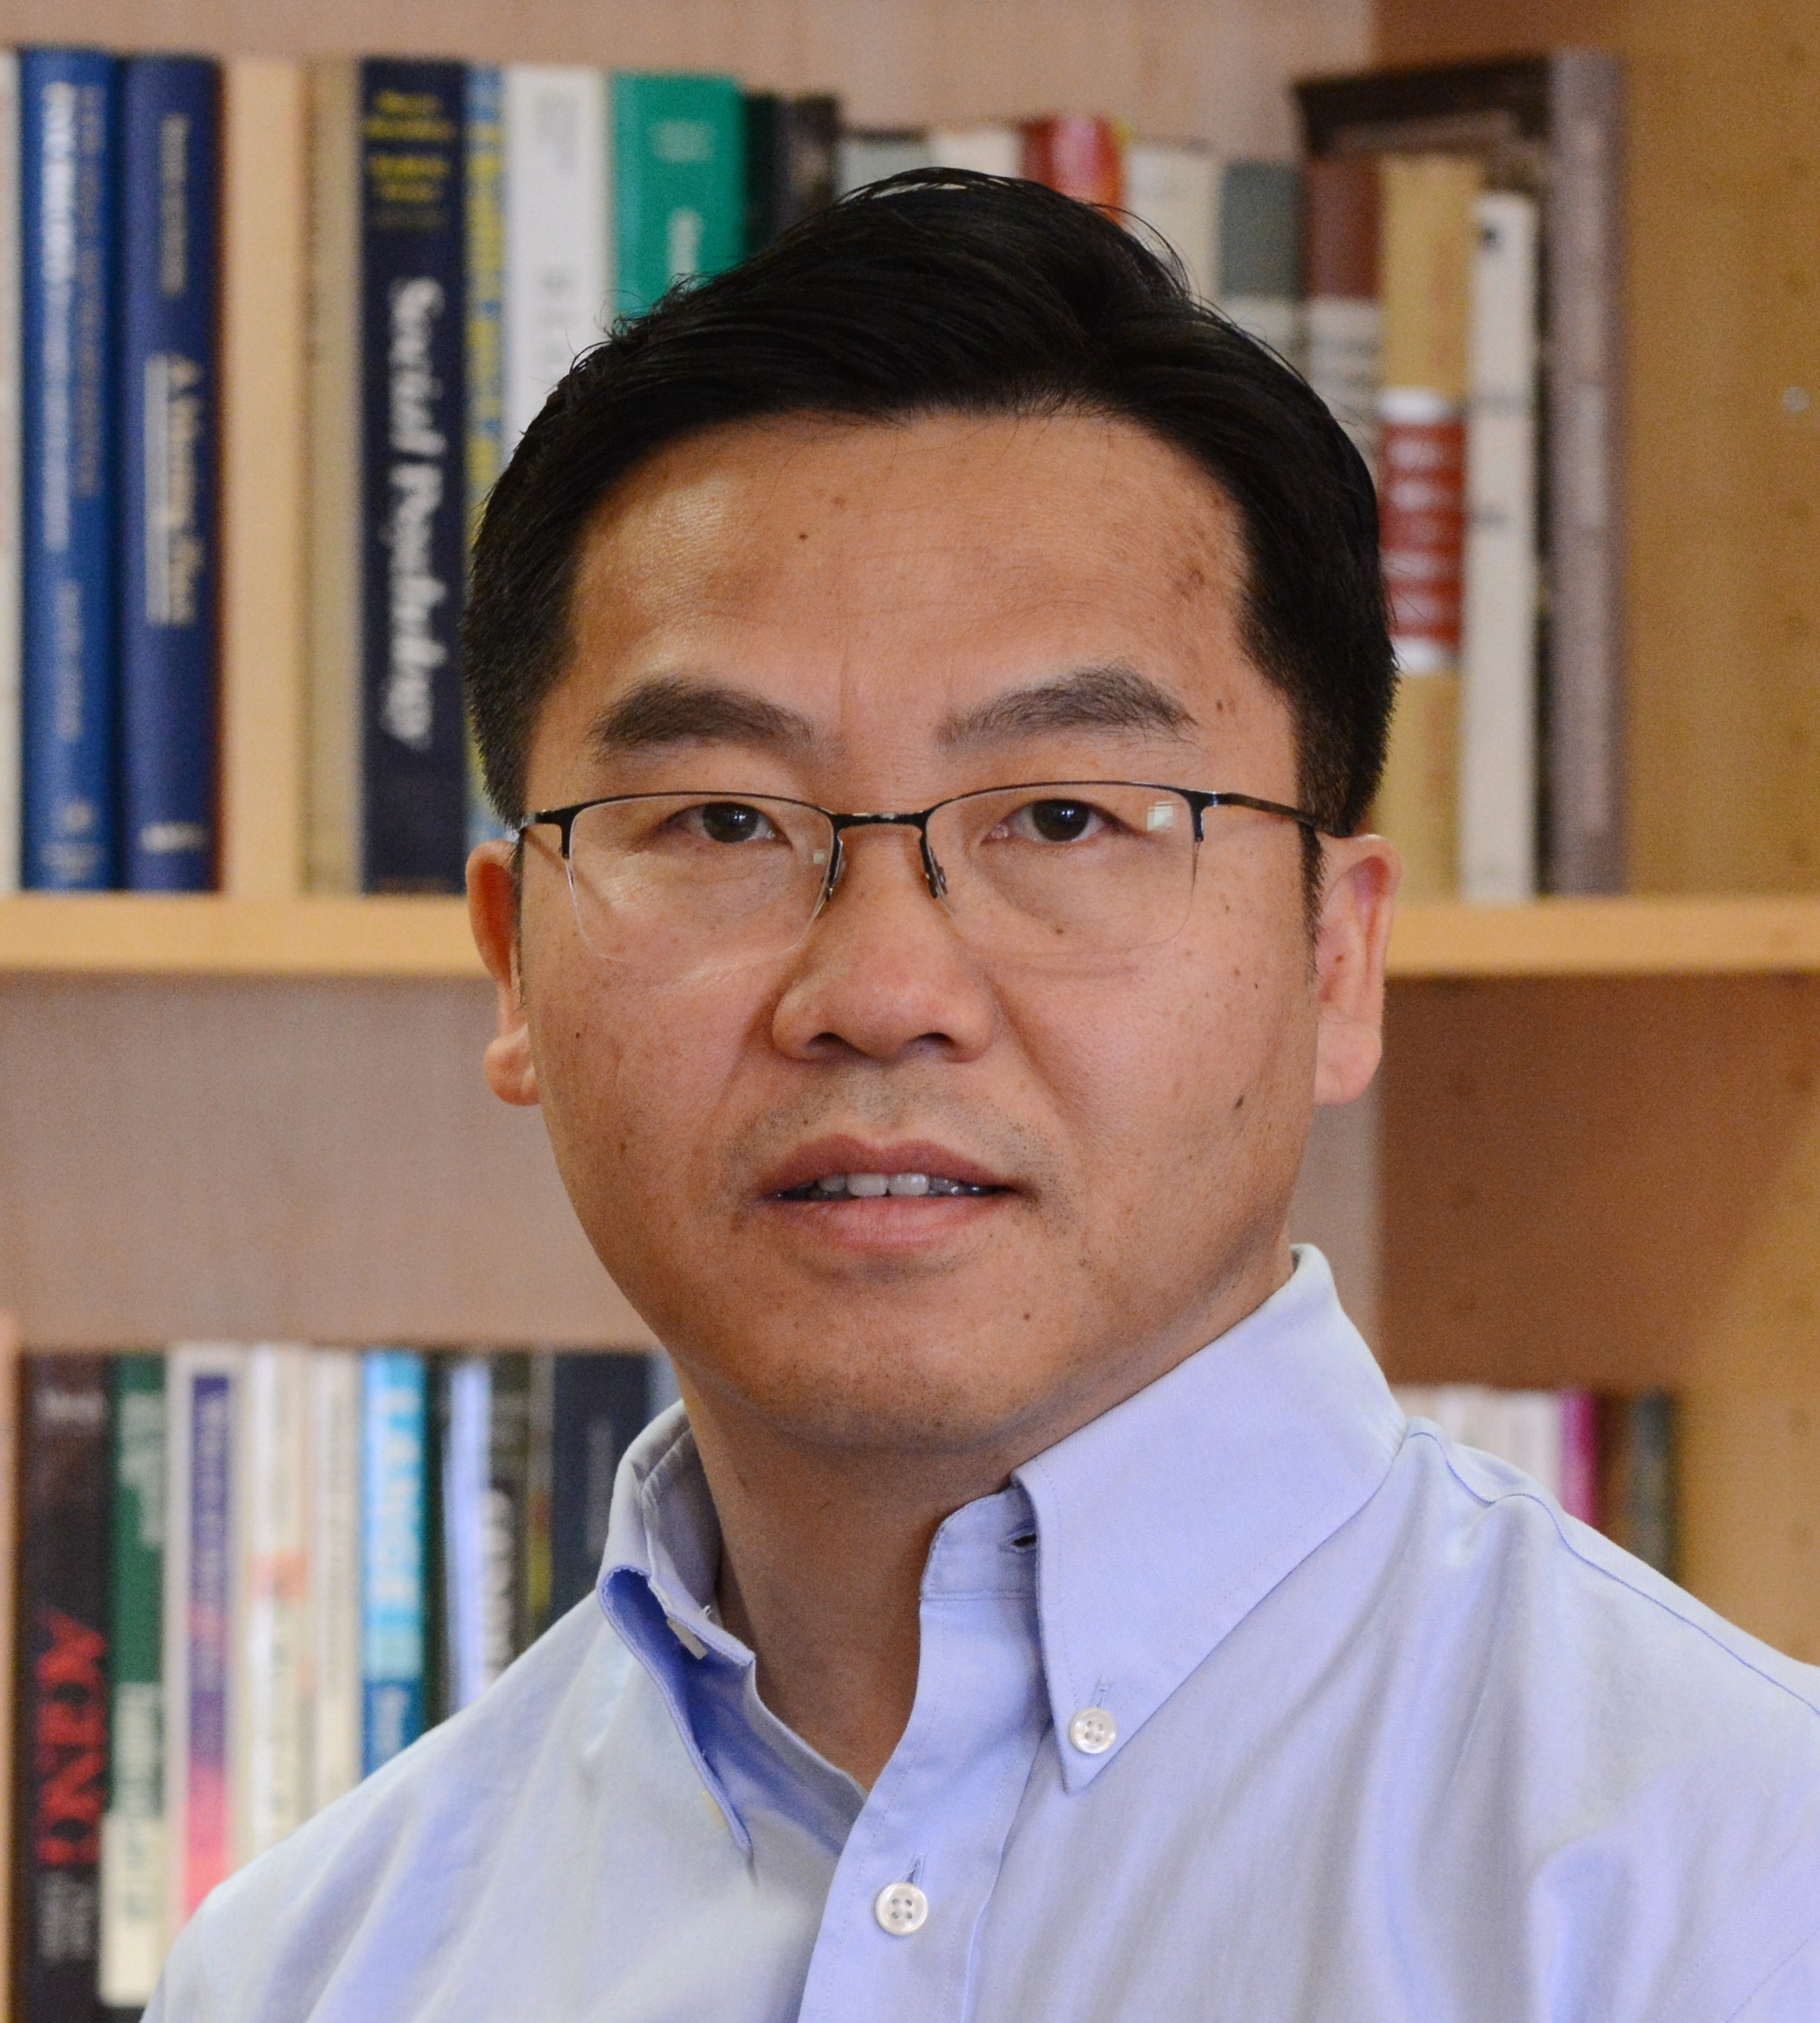 Professor of Biostatistics, Department of Biostatistics, Mailman School of Public Health, Columbia University

Candidates for ICSA 2021 Board of Directors
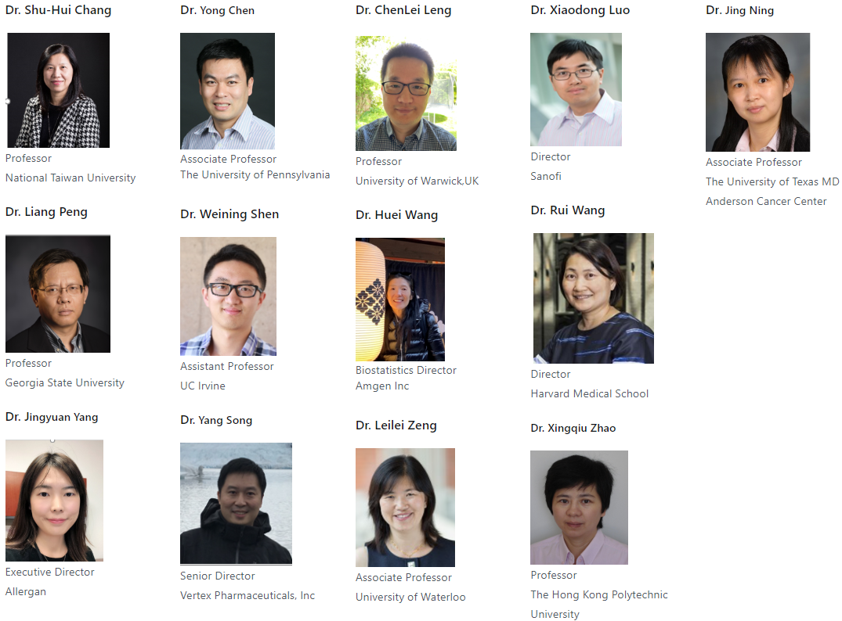
Please visit https://www.icsa.org/candidates-for-2021-board-of-directors/ and click each candidate’s name for more information.

ICSA 2020 Applied Statistics Symposium (Postponed to December 13-16, 2020)
Important Update
Due to the outbreak of COVID-19, the Organizing Committee has decided to postpone our conference to December 13-16 (Sunday-Wednesday), 2020 at The Westin Galleria Houston, 5060 W Alabama Street, Houston, Texas. The new deadlines for abstract submission and early-bird registration have been set up as follows:
· Early-bird registration deadline: October 15, 2020
· Deadline for the invited talk abstract submission: October 15, 2020
· Deadline for poster abstract submission: October 31, 2020
All the conference activities and events (including Tuesday banquet and half-day discount tour on Wednesday) will be scheduled accordingly. For those who cannot attend the conference because of the date change, we will refund all the fees you have paid. You may submit your refund request to symposium2020@icsa.org by October 31, 2020. No refund will be issued if registration is canceled after October 31, 2020. We will send an email to all session organizers, invited speakers, poster presenters and other registered colleagues for more details later. If you have any questions or concerns, please also send an email to symposium2020@icsa.org.
Please visit https://symposium2020.icsa.org/ for details including the key dates.

Call for Poster Awards Applications
Eligible poster presenters will be considered for poster awards. A student, postdoc, junior faculty, or junior statistician with PhD or terminal degree conferred in 2016 or later, who is also the first author of the poster and completes the symposium registration, is eligible for the poster award competition. The student paper award winners are not eligible for the poster award. Three to six poster award winners will be selected based on the evaluation criteria below and will be announced at the conference banquet. Each winner will receive a monetary prize ($550 for each prize) and an award certificate.

Poster award evaluation criteria:
- Statistical methodology and theories: novelty and appropriateness
- Applications: significance, importance, and impact
- Poster quality: style, organization, and visuals
- Presentation quality: clear presentation and proactive interactions with poster viewers

The abstract of the poster should be submitted through the ICSA 2020 Applied Statistics Symposium online system by October 31, 2020. Each poster will be assigned a poster number. All the posters should be hanged on the poster boards before 6PM on December 14, 2020. More detailed instructions for poster size, preparation and production will be available on the symposium website. For those who are eligible and are willing to participate in the poster award competition, you need to check the box of “eligible for the poster award competition” and register before October 31, 2020.

Executive Committee
      - Executive Committee Chair: Hulin Wu (University of Texas Health Science Center at Houston)
      - Scientific Program Chair: Momiao Xiong (University of Texas Health Science Center at Houston) and Jianhua Huang (Texas A&M University)
      - Program Book and Website Committee Chair: Yunxin Fu and Ashraf Yaseen (University of Texas Health Science Center at Houston)
      - Local Committee Chair: Hongyu Miao (University of Texas Health Science Center at Houston)
      - Treasurer: Dejian Lai (University of Texas Health Science Center at Houston)
      - Student Paper Competition Committee Chair: Ruosha Li (University of Texas Health Science Center at Houston) and Jing Ning (University of Texas MD Anderson Cancer Center)
      - Poster Session Committee Chair: Dr. Xi Luo, Associate Professor, University of Texas Health Science Center at Houston
      - Short Course Committee Chair: Wenyi Wang (University of Texas MD Anderson Cancer Center)
      - Fundraising Committee Chair: Rui (Sammi) Tang (Servier Pharmaceuticals)
Dr. Hulin Wu at The University of Texas Health Science Center at Houston (hulin.wu@uth.tmc.edu) chairs the Organization Committee.

2020 NISS Writing Workshop (Virtual) for Junior Researchers (at JSM August 2 & 4, 2020)
ICSA is proud of being one of the sponsors for this virtual workshop which is designed for researchers with a Ph.D. awarded or anticipated during 2014-2020 in statistics, biostatistics or related field.
Attendance at the Writing Workshop will be limited and applicants within 0-6 years’ post-PhD and members of the participating societies will receive preference.

If you are interested in this workshop, please refer to the below link for detailed information including registration:
https://www.niss.org/events/2020-niss-writing-workshop-junior-researchers-jsm

ICSA Springer Book Series in Statistics
The editor of ICSA Springer book series in statistics, Dr. Din Chen, has reported that there are 13 books in the series now. If you plan to write books in the series, please contact Dr. Din Chen (dinchen@email.unc.edu). The following 2 books were published in 2019:
1) Contemporary Biostatistics with Biopharmaceutical Applications. (Editors: L. Zhang, D.D.-G. Chen, H. Jiang, G. Li, H. Quan)
2) Statistical Quality Technologies Theory and Practices (Editors: Lio, Y., Ng, H.K.T., Tsai, T.-R., Chen, D.-G)

The following 6 books were published in 2018:
1) Biopharmaceutical Applied Statistics Symposium, Volume 1 Design of Clinical Trials (Editors: Peace, K.E., Chen, D.-G., Menon, S.)
2) Biopharmaceutical Applied Statistics Symposium, Volume 2 Biostatistical Analysis of Clinical Trials (Editors: Peace, K.E., Chen, D.-G., Menon, S.)
3) Biopharmaceutical Applied Statistics Symposium, Volume 3 Pharmaceutical Applications (Editors: Peace, K.E., Chen, D.-G., Menon, S.)
4) Proceedings of the Pacific Rim Statistical Conference for Production Engineering: Big Data, Production Engineering and Statistics (Editors: Choi, D., Jang, D., Lai, T.L., Lee, Y., Lu, Y., Ni, J., Qian, P., Qiu, P., Tiao, G.)
5) Statistical Analysis of Microbiome Data with R (Editors: Xia, Y., Sun, J., Chen, D.-G.)
6) New Frontiers of Biostatistics and Bioinformatics (Editors: Zhao, Y., Chen, D.-G.)

The following 5 books were published in 2017:
1) "Monte-Carlo Simulation-Based Statistical Modeling" (Editors: Chen, Ding-Geng, Chen, John Dean);
2) "Phase II Clinical Development of New Drugs" (Editors: Ting, N., Chen, D.-G., Ho, S., Cappelleri, J.C.).
3) "Biased Sampling, Over-identified Parameter Problems and Beyond" (Authors: Qin, Jing)
4) "Statistical Modeling for Degradation Data" (Editors: Chen, D.-G., Lio, Y., Ng, H.K.T., Tsai, T.-R.)
5) "New Advances in Statistics and Data Science" (Editors: Chen, D.-G., Jin, Z., Li, G., Li, Y., Liu, A., Zhao, Y.)
Thanks to all authors who contributed to these books.
1) https://www.springer.com/us/book/9789811033063
2) https://www.springer.com/us/book/9789811041921
3) https://www.springer.com/us/book/9789811048548
4) https://www.springer.com/us/book/9789811051937
5) https://www.springer.com/us/book/9783319694153

Sponsored and Co-Sponsored Journals

Statistica Sinica
Forthcoming papers' information is available at http://www3.stat.sinica.edu.tw/statistica/. The new issue (Volume 30, Number 2, 2020) is published.
ICSA members have access to these articles via the "membership only area" at http://www.icsa.org. If you have any problems with subscription, please contact the editorial office through ss@stat.sinica.edu.tw.

Statistics in Biosciences
The published new issue is Volume 12 Issue 1 in April 2020
https://rd.springer.com/journal/12561/12/1
Recently accepted articles can be found at the journal website
https://link.springer.com/journal/12561/onlineFirst/page/1
A link for submitting your article to SIBS online is below
https://www.editorialmanager.com/sibs/default.aspx

Statistics and Its Interface (SII) Call for Papers
Statistics and Its Interface is an international statistical journal promoting the interface between statistics and other disciplines including, but not limited to, biomedical science, geosciences, computer sciences, engineering, and social and behavioral sciences. The journal publishes high-quality articles in broad areas of statistical science, emphasizing substantive problems, sound statistical models and methods, clear and efficient computational algorithms, and insightful discussions of the motivating problems. Visit SII's web page at
http://intlpress.com/site/pub/pages/journals/items/sii/_home/_main/ for more information on the most recent issue (Volume 13 (2020), Number 3).
International Press and Tsinghua University Mathematical Science Center are pleased to announce open online access (free of charge) to the journal Statistics and Its Interface (SII) which includes thirteen volumes.

Statistics and Its Interface (SII) invites submissions for a special issue on Recent Developments in Complex Time Series Analysis. Research in time series analysis has been rapidly expanding during the last few decades, and massive time series with complex forms and structures appear from many fields including economics, finance, engineering, medicine and environmental sciences. This motivates the surge of new methodologies for estimation, prediction and computation, and also raises all kinds of challenges. SII promotes the interface between statistical theory, methodology and applications. Thus, we strongly encourage innovative theory, methodology and novel applications in complex time series analysis in both time and frequency domains, and it includes, but not is not limited to, Bayesian dynamic learning, financial time series, high-dimensional data, image data analysis, signal processing, etc. Your papers, once accepted, will be published together in a special issue of SII.

The submission deadline for the special issue is March 1, 2021. All submissions must be online through the website
http://www.e-publications.org/ip/sbs/index.php/index/login.
Please state that your submissions are “For the Special Issue on Recent Developments in Complex Time Series Analysis” in the Box of Comments to the editors. The submissions will go through regular review process. As the editors for this special issue, we will handle the peer review timely and carefully.

With your support and collaboration, we are confident that the special issue will be a success that will reflect the state-of-art of research at the frontier of this vital and rapidly developing area. We look forward to receiving your papers in due course.

Robert T. Krafty (Co-Guest Editor), University of Pittsburgh
Guodong Li (Co-Guest Editor), University of Hong Kong
Anatoly Zhigljavsky (Co-Guest Editor), Cardiff University

Ming-Hui Chen (Co-Editor-in-Chief), University of Connecticut
Yuedong Wang (Co-Editor-in-Chief), University of California, Santa Barbara

Upcoming ICSA Meetings
Please find below a list of upcoming ICSA meetings. This list also appeared on the ICSA website. Meetings not included in this list are not official ICSA meetings. If you have any questions, please contact Dr. Mengling Liu, the ICSA Executive Director
(executive.director@icsa.org).

ICSA 2020 Applied Statistics Symposium (Postponed to December 13-16, 2020)
Please refer to this link for details and updates.

ICSA 2021 China Conference (July 2 – 5, 2021)
The 2021 ICSA China Conference will be held at Xian University of Finance and Economics, Xian, China from July 2 - 5, 2021. For information, please contact Scientific Program Committee Co-Chairs Professor Yingying Fan at fanyingy@marshall.usc.edu and Professor Chunjie Wang at wangchunjie@ccut.edu.cn.

Call for Invited Session Proposals
The conference scientific program committee welcomes invited session proposals. An invited session consists of either 4 presenters or 3 presenters and 1 discussant. The one-talk rule will be applied (i.e., each speaker can only give one invited talk). It is required to confirm all speakers’ availability before the proposal submission. Please send your proposal to one of the Co-Chair mentioned above before August 16, 2020. The acceptance of invited sessions will be determined by November 15, 2020. In order to secure the invited session slot, the presenters will be required to register to the conference and submit the abstracts online by March 31, 2021.

ICSA 2022 China Conference (July 1 – 4, 2022)
ICSA 2022 China Conference will be held at Chengdu from July 1 to July 4, 2022, co-sponsored by Southwest Jiaotong University (SWJTU).

Upcoming Co-Sponsored Meetings
Please find below a list of upcoming ICSA co-sponsored meetings. This list also appeared on the ICSA website. Meetings not included in this list are not officially co-sponsored meetings. If you have any questions, please contact Dr. Mengling Liu, the ICSA Executive Director (executive.director@icsa.org).

Duke-Industry Statistics Symposium (August 26 -28, 2020)
Given evolving public concerns regarding COVID-19 and the potential travel uncertainties, the annual Duke-Industry Statistical Symposium (DISS) will be postponed from April to August. The symposium will be held from August 26 to August 28, 2020 at Durham Hilton, Durham, NC. For further details regarding this update, please click this link: https://sites.duke.edu/diss/postponement-message/
The theme of the symposium is “Emerging Initiatives in Pharmaceutical Development: Methodology and Regulatory Perspectives.” The first day will be devoted to six short courses. The second day and the third day morning are consisted of keynote speeches and 25 parallel sessions. The symposium was established 8 years ago to discuss challenging issues and recent advances related to the clinical development of drugs, biologics and devices and to promote research and collaboration among statisticians from industry, academia, and regulatory agencies.

More details about program, registration, short course, poster session, and travel information for this two-and-half-day symposium can be found at the symposium website https://sites.duke.edu/diss.

The 8th Workshop on Biostatistics and Bioinformatics (Tentative Fall, 2020)
Biostatistics and Bioinformatics have been playing key and important roles in statistics and other scientific research fields in recent years. The goal of the 8th workshop is to stimulate research and to foster the interaction of researchers in Biostatistics & Bioinformatics research areas. The workshop will provide the opportunity for faculty and graduate students to meet the top researchers, identify important directions for future research, facilitate research collaborations. The workshop will be held at Atlanta, GA.
A keynote speaker is Dr. Nilanjan Chatterjee, Bloomberg Distinguished Professor of Biostatistics and Medicine at the Johns Hopkins University.
For detailed information including registration, please refer to https://math.gsu.edu/yichuan/2020Workshop/

IMS Asia Pacific Rim Meeting (January 5–8, 2021)
The sixth meeting of the Institute of Mathematical Statistics Asia Pacific Rim Meeting (IMS-APRM) will provide an excellent worldwide forum for scientific communications and collaborations for researchers in Asia and the Pacific Rim, and promote collaborations between researchers in this area and other parts of the world. The meeting will be held in Melbourne, Australia and please see http://ims-aprm2021.com/ for details.

Online Training Program
Online training serves as a viable alternative to traditional continuing education options, e.g., to short courses offered at biostatistical conferences. Over the past year, the ASA Biopharmaceutical Section has been working on creating an online training program aimed at clinical trial statisticians and set up a pilot program, which includes half-day and full-day courses on key topics in biopharmaceutical statistics:
Analysis of Longitudinal and Incomplete Data
Multiplicity Issues in Clinical Trials
Analysis of Surrogate Endpoints in Clinical Trials
The section has received much positive feedback from industry and academic statisticians. Clinical trial statisticians who took advantage of the online training program emphasized that this program is convenient, inexpensive and quite flexible.

A similar online training program has been set up for ICSA members. As a member of the ICSA, you will receive a 50% discount when you sign up for any course included in the program. The online training courses are based on professionally recorded videos using a format similar to that used in YouTube videos. The videos can be accessed 24/7 on a computer or even on a smartphone. The cost of online training is low compared to traditional training, and it can be further reduced by using a group-training format. Up to 25 people can view an online training course with a single registration, which lowers the cost of online training to about $20-25 per person for full-day courses and $10-15 per person for half-day courses.
For more information about the online training program and to sign up for the individual online courses, please visit this web page:
http://sprmm.com/icsa/

Machine Learning Boot Camp: Analyzing Biomedical and Health Data (June 8-9, 2020)

COVID-19 Update: The Machine Learning Boot Camp will no longer take place in person due to the COVID-19 pandemic. The Boot Camp will instead be a live-stream, remote training that takes place over live, online video on June 8-9, 2020 from 10am EDT - 4pm EDT. Please note this training is not a self-paced, pre-recorded online training.

The Machine Learning Boot Camp is a two-day intensive boot camp of seminars combined with hands-on R sessions to provide an overview of concepts, techniques, and data analysis methods with applications in biomedical research.

INSTRUCTORS
Noah Simon, PhD, Department of Biostatistics, School of Public Health, University of Washington.
Yifei Sun, PhD, Department of Biostatistics, Mailman School of Public Health, Columbia University.
Cody Chiuzan, PhD, Department of Biostatistics, Mailman School of Public Health, Columbia University.

Investigators at all career stages are welcome to attend, and we particularly encourage trainees and early-stage investigators to participate.

PREREQUISITES AND REQUIREMENTS
There are three prerequisites/requirements to attend:
1. Each participant must have an introductory background in statistics.
2. Each participant must be familiar with R. The main software used for the workshop will be R/RStudio, therefore we strongly recommend that participants have a basic understanding of this software prior to attending the Training.
3. Each participant is required to bring a personal laptop with R/RStudio installed prior to the first day of the workshop, as all lab sessions will be done on your personal laptop. R is available for free download and installation on Mac, PC, and Linux devices.

If you have any specific questions about R and R studio in the context of the Machine Learning Boot Camp, please email us.

For more details and to subscribe for updates; email us at Columbia.MachineLearning@gmail.com.
Website: mailman.columbia.edu/Machine-Learning
Capacity is limited. Paid registration is required to attend.

Healthcare Innovation Technology: The Pod of Asclepius
Looking to stay up to date on developments in health care technology around the world? The American Statistical Association is sponsoring “The Pod of Asclepius”, a new podcast where data scientists, statisticians, engineers, and regulatory experts discuss the technical challenges in their healthcare domain.

We have over 20 episodes published and available on YouTube, Podbean, iTunes, Stitcher, Podchaser, Tune In Radio, and Google Play.

Looking for a good place to start? Check out the following episode links:
- Risks and Opportunities of AI in Clinical Drug Development with David Madigan and Demissie Alemayehu
- Kidney Injury - Biomarkers for Prediction and Prognosis with Allison Meisner
- NHS Digital Health Initiatives with Emma Hughes
- Data Platforms to Monitor Animal Health with Shane Burns
- Bayesian Approaches in Medical Devices: Part 1, Part 2, Part 3 with Martin Ho and Greg Maislin

You can catch up on all episodes on our YouTube playlists for Season 0 and Season 1.

The easiest way to catch new episodes is to subscribe via our channels….
Youtube: https://www.youtube.com/channel/UCkEz2tDR5K6AjlKw-JrV57w
Podbean: https://podofasclepius.podbean.com
You can see our full schedule on the website: www.podofasclepius.com

Job Listings
Faculty Positions in the Department of Applied Mathematics, National Sun Yat-sen University, Taiwan, ROCThe Department of Applied Mathematics at National Sun Yat-sen University invites applications to fill a full-time faculty position (subject to the approval by the University) beginning on February 1, 2021. Positions at the rank of assistant professor are open for young researchers with a solid research background, while all ranks are open for senior scholars. International applicants are welcome. A successful candidate must have a doctorate in mathematics or statistics, and should have a strong research record and excellence in teaching. All areas of mathematics, applied mathematics, scientific computing, probability and statistics will be considered. Applicants should send, by September 14, 2020, a cover letter of application, curriculum vitae, transcripts, research statement and publications list to

Chairperson
Department of Applied Mathematics, National Sun Yat-sen University, Kaohsiung 804, Taiwan, R.O.C.
Email: head@math.nsysu.edu.tw
Tel : +886-7-5252000 ext. 3800, 3834; Fax: +886-7-5253809
Website: http://www.math.nsysu.edu.tw

Applicants should arrange three letters of recommendation sent directly to the above address.

Founding Faculty in the Information Hub (Data Science and Analytics (DSA)
The Hong Kong University of Science and Technology (HKUST) invites applications for founding faculty positions at all levels at Professor, Associate Professor and Assistant Professor rank in Data Science and Analytics (DSA) for its new campus in Guangzhou (GZ). The Data Science and Analytics thrust area focuses on unifying statistics, machine learning, optimization, and their related techniques. By analyzing and modeling data, the Hub aims to transform analytics into industrial and business insights for effective decision making. The initial focus areas include, but not limit to, data-driven AI & machine learning, statistical learning and modeling, industrial and business analytics (operations-related data analytics, business intelligence and strategy, etc.), and sector-specific data analytics (healthcare, finance, insurance, marketing, manufacturing, transportation, etc.). Candidates for all ranks must have a PhD degree in related disciplines and should have demonstrated ability to pursue high impact research in the areas of data science and analytics.

About HKUST Guangzhou Campus [https://gz.ust.hk/]
HKUST(GZ) offers a unique educational environment with four transdisciplinary hubs and 16 thrust areas. HKUST(GZ) offers superb research facilities, attracting top international faculty and students to conduct curiosity-driven and goal-oriented research to address the world’s pressing scientific and technological challenges. English is the medium of instruction and administration at HKUST (GZ).

HKUST(GZ) is situated in Nansha District, Guangzhou, which is right in the center of the Greater Bay Area, one of the most vibrant and dynamic regions in the world, neighboring Shenzhen, Hong Kong, and Macao. It is about 30 minutes away from Hong Kong by high-speed train. The new campus is under construction and is planned to open in 2022. Successful candidates may start working on the Clear Water Bay campus in Hong Kong before the new campus is completed.

About the Information Hub
The HKUST(GZ) Information Hub focuses on addressing global challenges arising from human interactions with information and technology in an era of digital transformation. The Hub is mainly comprised of four thrust areas: Artificial Intelligence, Data Science and Analytics, Future Communication Networks, and Digital Media and Arts. We have also established an Internet of Things (IoT) division focused on technology transfer and industrial projects. In each of these areas, we are committed to providing a world-class education and conducting cutting-edge research with practical applications, with the purpose of not only advancing regional development but also making a global impact.

Remuneration and Conditions of Service
Salary is highly competitive of international standard and will be commensurate with qualifications and experience. Generous research funds, ample laboratory space and excellent research equipment and support will be provided.

All posts are tenure-track Mainland China appointments to be offered by the HKUST Mainland entity in accordance with the local employment laws and regulations. Appointment to Professor rank and some Associate Professor rank will be made on substantive basis while initial appointment to other tenure-track faculty ranks will be made on a fixed-term contract of up to three years commencing the earliest in July/August 2020. Re-appointment thereafter will be subject to performance, mutual agreement and funding availability.

Application Procedure
Applications should be sent to <gzrecruitINF@ust.hk> together with (i) full CV; (ii) a statement of research, teaching, and service; (iii) up to five most representative publications in PDF formats; (iv) record of teaching performance (if any); and (v) names and contact information of three referees. Review of applications will continue until the positions are filled.
Job ID: 5215

Electronic ICSA News Access
Please visit http://www.icsa.org/icsa/news/newsletter for all ICSA member news online.

